A Work – Full Moon
The list below of full moons in 2001 was taken from the Farmer’s Almanac. Who do you think named these moons? Why do you think these names were chosen?

Write a myth or story that would explain the moon’s name. (An example is located on the back of the paper). Your story must involve the Moon as a character and must explain why the Moon does a particular thing. You are limited only by your imagination. Must be typed.
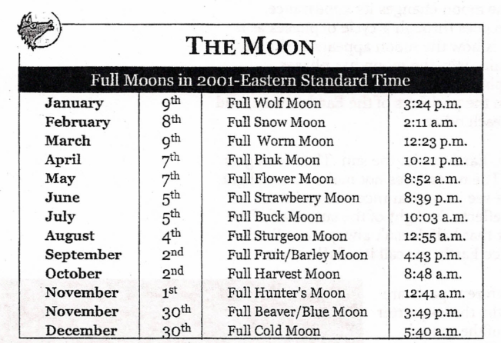

Rubric:
Content: 8 Points
- Included a clearly presented central idea with relevant facts,supporting details, and/or explanation.
- Establishes well-developed characters and/or situation/plot
Organization: 5 Points
- Organizing structure is very clear and includes paragraphs and effective transitions words/phrases.
- Has a thoroughly developed sequence of significant events or time order that strongly engages the reader and moves to a powerful conclusion.
Conventions: 2 Points
- Contains 3 or less errors in conventions that make the writing easy to read and understand.

