A Work Graph Sunspots
During which years were electrical disturbances on Earth most common? In this activity, you will consider the relationship between sunspot activity and magnetic storms on Earth.
Problem
How are magnetic storms on Earth related to sunspot activity?

Instructions
- Use the data in the table to plot a line graph of sunspot activity between 1972 and 2002. Use the graph on the next page.
- On the graph, label the x-axis “Year.” Use a scale with 2 year intervals, from 1972 to 2002.
- Label the y-axis “Sunspot Number.” Use a scale of 0 through 160 in intervals of 10.
- Graph a point for the Sunspot Number for each year.
- Complete your graph by drawing lines to connect the points.
- Answer the questions (they do not need to be typed).
- Turn in only the graph/question page

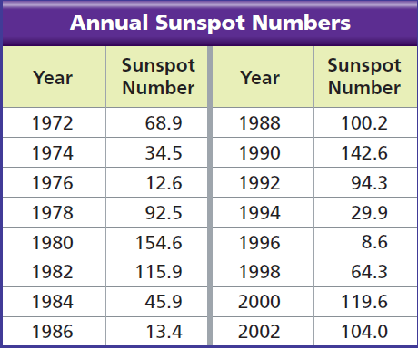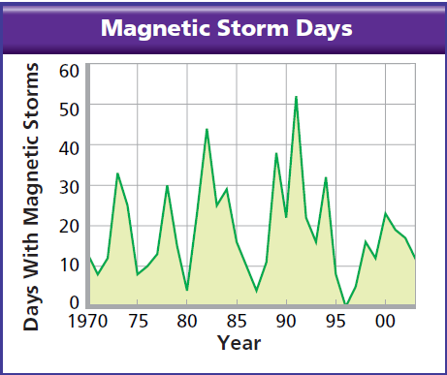

Name ____________________________________________________________ Period ________
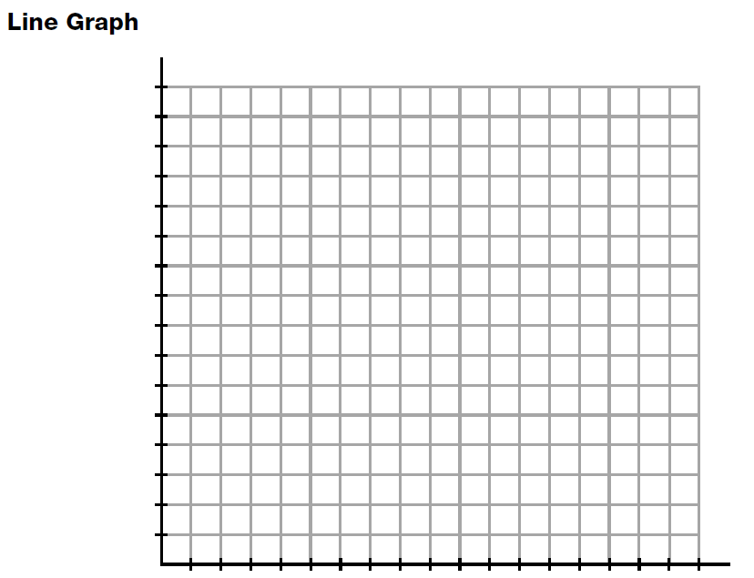

- Based on the graph, which years had the highest average sunspot number? ________ The lowest average sunspot average? ___________

- How often does the cycle of maximum and minimum repeat? _________________

- When was the most recent maximum sunspot activity? _________ The most recent minimum activity? _______

- Compare the sunspot graph with the magnetic storms graph. What relationship can you infer between periods of high sunspot activity and magnetic storms?

- Use the pattern of sunspot activity you found, predict the number of peaks you would expect in the next 30 years. ____________________ Around what years would you expect the peaks to occur?______________

- Suppose you are an engineer working for an electric power company. Write a brief summary of your analysis of sunspot activity. Explain the relationship between sunspot number and electrical disturbances on Earth. Use data from the charts/graphs in your answer.

