Name ______________________________________________________ Period ______
A Work Heat and Human Health
Directions: Answers must be typed to be accepted.
- Read the information below. Use both the reading and the figure below to answer the 4 questions.
  - Use a separate piece of paper to answer the questions. The answers must be typed.
  - Title your paper properly: Assignment title (A Work: Heat...), name and period number
  - Answer the questions completely, remember, this is an A assignment.

Heat and Human Health
Extremely hot weather can be dangerous to human health. During a heat wave, the body struggles to maintain a healthy temperature of about 98.6°F. Heat stress may set in before the air temperature exceeds this mark, however, because the body also produces heat when it does work. The figure below shows how the brain and body respond to excessive heat.
The additional stress this response places on the heart and blood vessels can trigger heart and other medical problems, especially in the elderly. Because of this, death rates often rise when a heat wave strikes.
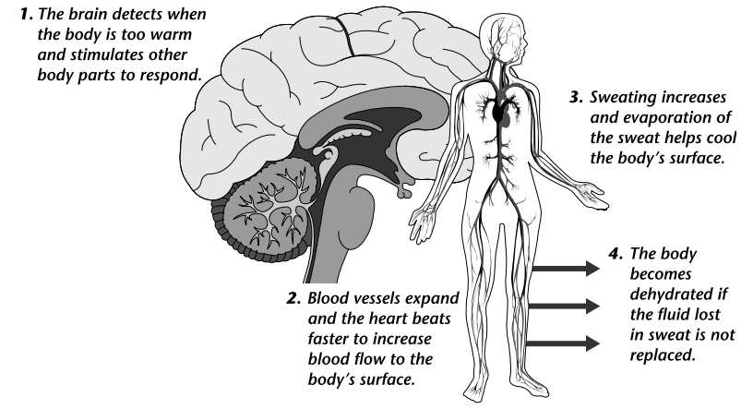
- Heat can be lost from the body in the same ways that heat is lost from Earth’s surface, that is, by radiation, conduction and convection. Based on what you know about heat transfer from Earth’s surface to the atmosphere, describe how the body can lose heat in each of these ways.
- The body also loses heat by the evaporation of sweat. How is a tea kettle boiling on the stove similar to the evaporation of sweat from the body?
- You lose heat only from the surface of your body, so the warmer your body surface, the more quickly you cool down. When you are overheated, your blood vessels expand, allowing your blood to carry more heat from deep inside your body to your body surface. Explain how this helps cool your body.
- Why are you more likely to become dehydrated in hot weather?

