Name: ________________________________________________________________ Period: ________
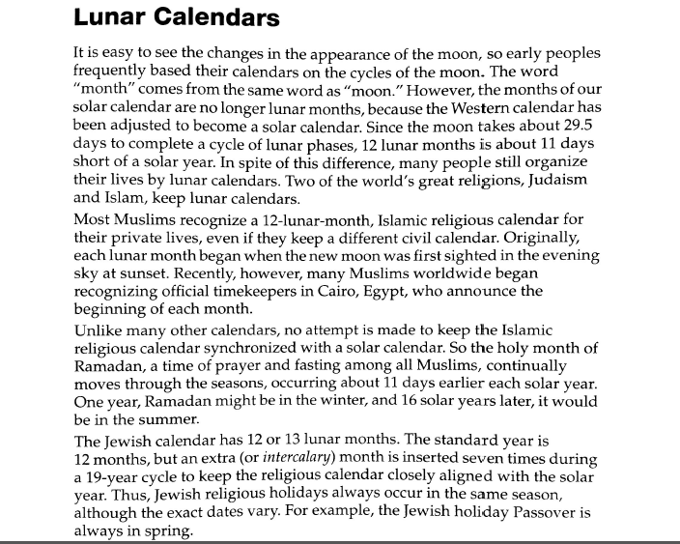
Answer the following questions.
- How many days in a lunar “year” of 12 lunar months? ________________________________________________________________________
- How many days are in a solar year?
________________________________________________________________________
- Not counting leap years, how many days are in 19 solar years? ________________________________________________________________________
- How many days are in 19 lunar calendar years with an extra month added in seven times? __________________________________________________________________
- How closely does the Jewish calendar coincide with the solar calendar every 19 years?
________________________________________________________________________
- Why might it be important for farmers and hunters to keep their calendar aligned with the seasons? ________________________________________________________________________________________________________________________________________________________________________________________________________________________________________________________________________________________________

