A Work – News Flash!
The list below of full moons in 2001 was taken from the Farmer’s Almanac. Choose 3 names and write a newspaper article that answers the questions: “Who named the moons?”, and “Why did they choose these names?”. Must be typed.

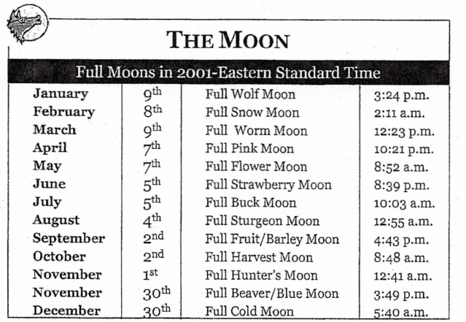
Rubric:
Layout: 3 Points
- Must look like a newspaper article (Headline and byline)
Body: 10 Points
- A body that contains the five W’s: who, what, when, where, why.
- Write three or four important details about the story.
- Fact based and unbiased.
Conventions: 2 Points
- Contains three or less errors in conventions that make the writing easy to read and understand.

