Name ______________________________________________________ Period ______
A Work Reflection of Solar Radiation
Directions: Answers must be typed to be accepted.
- Read the information below. Use both the reading and quote the figure below to answer the 5 questions.
  - Use a separate piece of paper to answer the questions. The answers must be typed.
  - Title your paper properly: Assignment title (A Work: Reflection..), name and period number
  - Answer the questions completely, remember, this is an A assignment.

Reflection of Solar Radiation
On average, about half of the sunlight that strikes Earth’s atmosphere reaches the surface of the planet to be absorbed and converted to heat. This absorbed light is a key factor in determining Earth’s temperature and weather. Also, it is crucial for the normal functioning of Earth’s greenhouse effect.
The other half of the sunlight that strikes Earth’s atmosphere is either absorbed by the atmosphere before it reaches the surface or reflected back into space by clouds or by Earth’s surface itself. The amount of sunlight that is reflected back into space in a particular place depends mainly on how thick the clouds are and whether Earth’s surface is dark or light. The figure below shows how much energy is reflected back into space with different thicknesses of cloud cover and different types of surface on Earth.

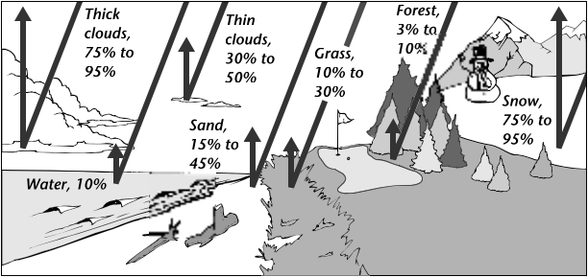

- Which two types of surface on Earth are most important for absorbing solar energy and keeping the planet warm? Explain your answer.
- Why do skiers often get sunburned even in winter, when the sun’s rays are not very strong?
- What effect would thick cloud cover have on the temperature of Earth’s surface? Explain your answer.
- Why might a major volcanic eruption lead to cooler temperatures over a large area around the volcano?
- Which do you think would be warmer on a winter day when there is not wind, a thick forest or a grassy field? Explain your answer.

