Air Masses, Fronts and Winds Review Guide Answer Key
To study for the test, answer and study the following questions.
- What causes winds? Differences in air pressure. Warm air creates low pressure areas and cold air creates high pressure areas. Air moves from areas of high pressure to areas of low pressure.

- How are local and global winds different from each other? Local winds occur over small areas and distances, global winds occur over a large area and distances.

- Draw a sea breeze and explain how it forms.
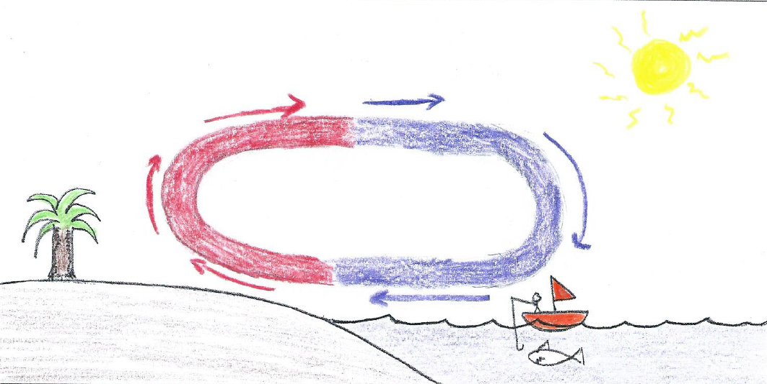
Sea breezes occur because land heats faster than water. The warmer land heats the air above it creating a low pressure zone and air moves from areas of high pressure to areas of low pressure.

- Draw a land breeze and explain how it forms.
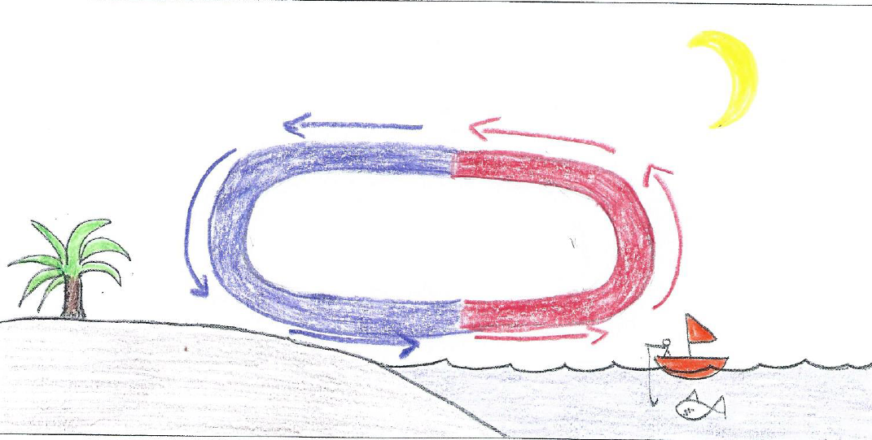
Land breezes occur because land cools faster than water. The warmer water heats the air above it creating a low pressure zone and air moves from areas of high
pressure to areas of low pressure.

- What is the Coriolis Effect? The Earth’s rotation makes winds curve

- What are the 3 most important instruments used to study and forecast the weather? Explain what each is used for.
Doppler Radar. They are used to track storms
Satellites: Used to track weather systems
Computers: Used to interpret large amounts of data

- What are the two major wind belts that effect weather in the continental United States? What direction does each blow?
Prevailing Westerlies blow west to east.
The Jet Stream blows west to east.

- In what direction do air masses/weather move across the United States? What causes this?
West to east. The prevailing westerlies and the Jet Stream

- Compare and contrast how a warm and cold front form. Draw the map symbol and include an arrow that shows the direction it is moving.
Same Different Symbol
Warm Front Different temperature air mass Warm air mass
over taking each other overtakes cold air mass

Cold Front Different temperature air mass Cold air mass overtakes
over taking each other warm air mass.

- What warms faster, soil or water? Soil

- What cools faster, soil or water? Soil

- How are air masses classified? By temperature, humidity and air pressure.

- Identify the 4 major types of air masses that affect the weather in the United States.
Name Humidity Temperature Where are they formed?

Maritime Tropical Humid Warm Over oceans
Maritime Polar Humid Cold Over oceans
Continental Tropical Dry Warm Over land
Continental Polar Dry Cold Over land

