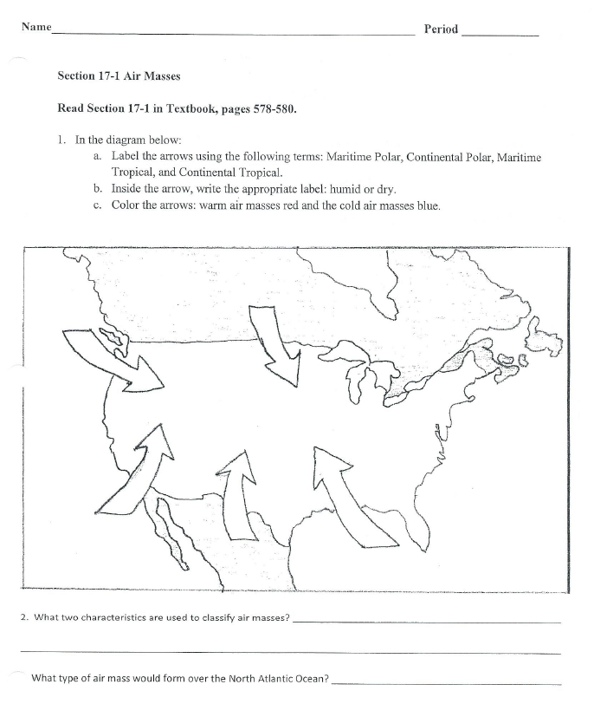

Name __________________________________________________________ Period _______

Air Masses Process Grid
Fill in the blanks in the table below.
Air Masses
TYPE | WHERE IT FORMS | TEMPERATURE | HUMIDITY
Maritime  Tropical | over ocean | warm | moist

