Independent Work Air Pressure in the Troposphere
Earth’s weather occurs in the troposphere, and air pressure is an important factor in weather.
Directions:
- Use the date on air pressure in Table 1 Altitude and Air Pressure to make a graph
showing how air pressure changes as you move upwards in the troposphere. Use the
graph paper provided.
- Anwer the questions on the back of the graph paper. They do not need to be typed.

Table 1 Altitude and Air Pressure
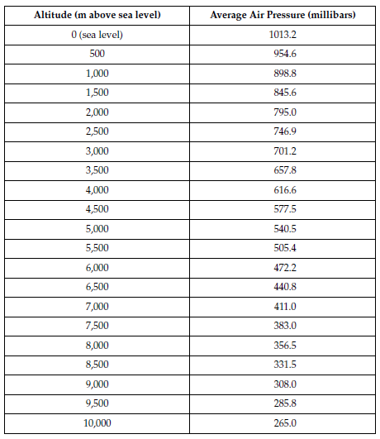

- Describe the relationship between altitude and air pressure shown on the graph.

- Estimate the average air pressure in a hole 500 meters below sea level?

- If you were flyng at an altitude of 1,500 meters, what would the air pressure outside the plane be? When you fly that high, why might your ears pop?

