Name ________________________________________________________ Period __________
Analyzing Data: Temperature Inside the Earth
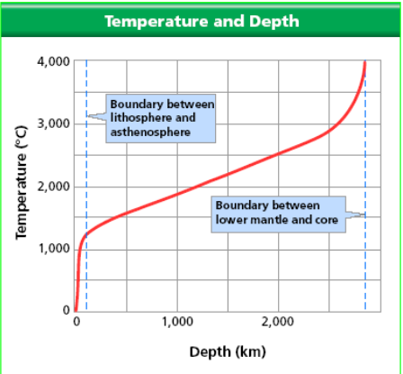

- As you move from left to right on the x-axis, how does the depth inside the Earth change?

____________________________________________________________________________

- What is the temperature at the boundary between the lithosphere and the asthenosphere?

____________________________________________________________________________

- What is the temperature at the boundary between the lower mantle and the core?

____________________________________________________________________________

- How does the temperature change with depth in Earth’s interior? Anwer in a complete sentence.

_____________________________________________________________________________

_____________________________________________________________________________

_____________________________________________________________________________

