Independent Work Atmospheres of Earth and Venus
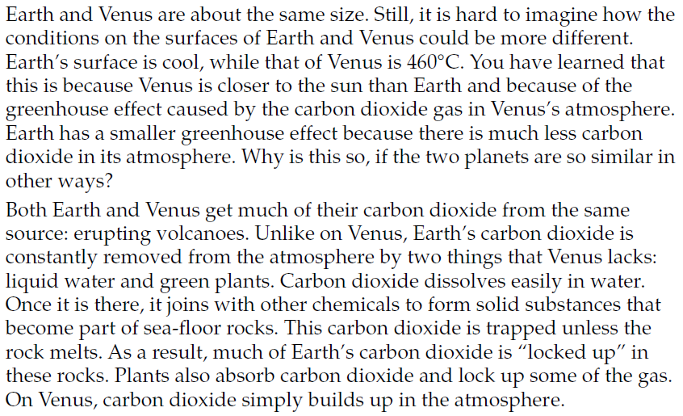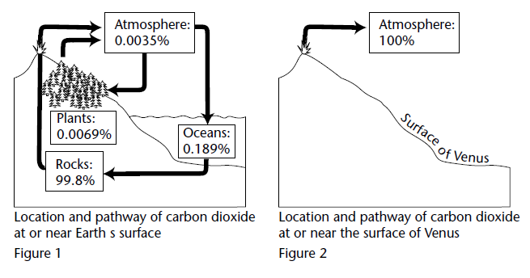
Use the reading and the diagrams to answer the questions below on a separate piece of paper. Must be typed to be accepted.
