B Work: Build a Simple Sundial
Moon, and Sun
Long before the invention of clocks, people measured time with sundials. A simple sundial is a vertical pointer projecting from a flat surface. Marks on the surface show where the shadow cast by the tip of the pointer falls at different times of day as Earth’s rotation causes the sun to move across the sky. You tell time by noting where the pointer’s shadow falls on these marks. Of course, for the shadow to fall in the right places, the sundial has to stay in one place. Therefore, sundials are usually built on permanent pedestals or as parts of buildings. Also, the position of the sun in the sky changes through the seasons, so the path of the pointer’s shadow changes over time. To build a simple sundial, you can start with two pieces of stiff poster board and masking tape.
■ On the first piece of poster board, draw the figure shown in Figure 1. Cut
it out, and then fold it along the dotted lines. This will become your
pointer.

■ On the second piece of poster board, draw the figure shown in Figure 2,
with the point of the angle close to a corner of the poster board. Now,
tape the pointer onto the second piece of poster board so that its base
lines up with the figure you have drawn. The finished sundial should
look like Figure 3.

■ Around midday, place the sundial on a stable, flat, sunlit surface such as
an outdoor table top, so that the pointer’s shadow falls towards the
opposite corner of the posterboard. Tape down the sundial so it won’t
move. Every half hour, mark the location of the shadow of the pointer ’s
tip and label it with the time. Continue this process throughout the
afternoon and again the next morning. This is how you “set your clock,”
when your clock is a sundial.

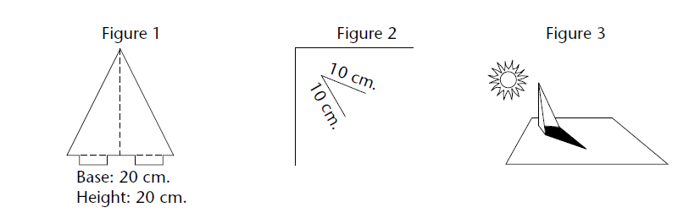

Answer the questions below on a separate sheet of paper.They must be typed!

1. At some moment when you don’t know what time it is, look at your
sundial and read the time. Compare your sundial time with the time on a
clock. How accurate is your sundial?

2. Do you think a “moondial” could be made to tell time at night? Explain.

3. Name two practical disadvantages of sundials compared with clocks.

