B Work: The Evolution of Lunar Landscapes
You already know that the surface of the moon has highlands and maria. Scientists think that the highlands of the moon could have formed a billion years before the maria. Remember, maria formed from lava that flowed across the moon’s surface. One way that astronomers estimate the age of a region on the moon is by counting its craters. If meteors are equally likely to hit any spot on the moon, older regions should have more craters per square kilometer because more meteors would have had a chance to strike them. This simple rule, along with a few others, enables astronomers to learn the order in which features on the moon were formed. Use this rule in the following activity.
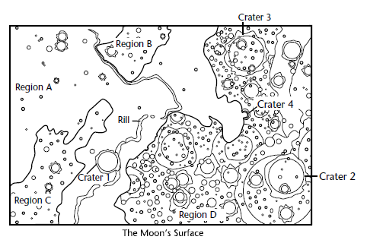

Answer the following questions on a separate sheet of paper. They must be typed.

1. In the map above, the heavy black lines mark the boundaries of four basic
regions: A, B, C, and D. The circular features are craters. Based on the
number of craters per unit of area, which region is probably the oldest?
Which is probably the youngest?

2. Several small craters lie in the floor and on the walls of crater 2. Which is
older, crater 2 or the small craters inside it?

3. Craters 2 and 3 have about the same area. Which one is probably older?
Why?

4. Region A is a mare. (Mare is the singular form of maria.) The others are
highlands. Notice how the material of region A fills crater 4. Which
formed first, region A or crater 4? Why?

5. The long structures in region A are rills. A rill is a kind of valley formed
when an underground tube collapses. Is the labeled rill older or younger
than region A? List the following in order of age, from oldest to youngest:
crater 1, crater 4, the labeled rill, and the floor of region A.

