B Work – Using Eclipses to Study Solar Winds Reading is on the website!
Name ______________________________________________________ Period ______
Instructions: Use the Reading to Answer the following questions.
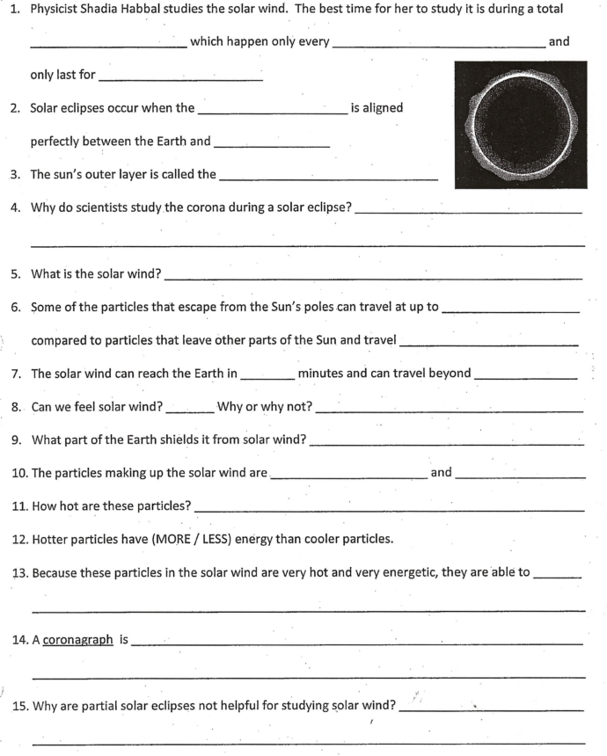

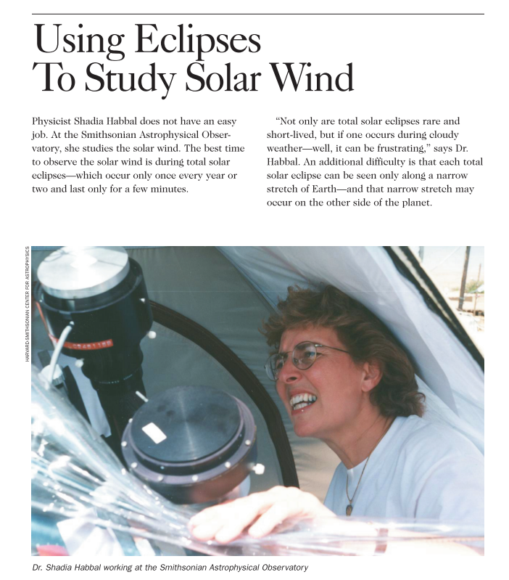

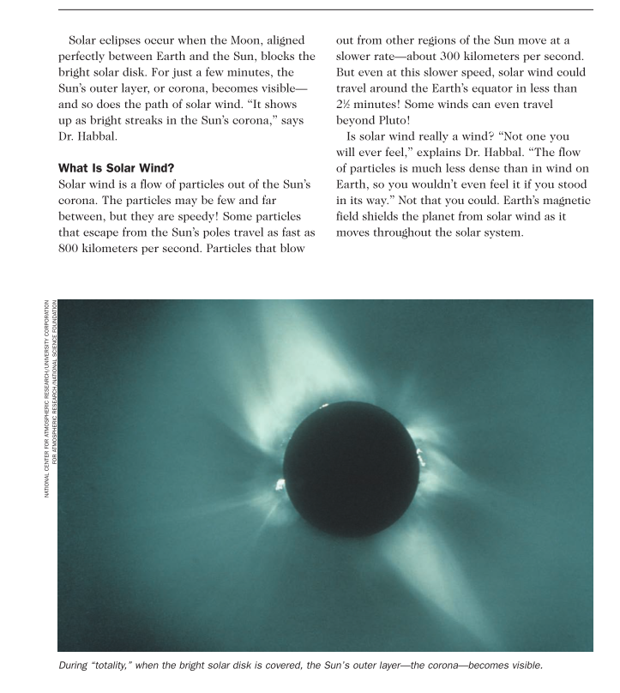

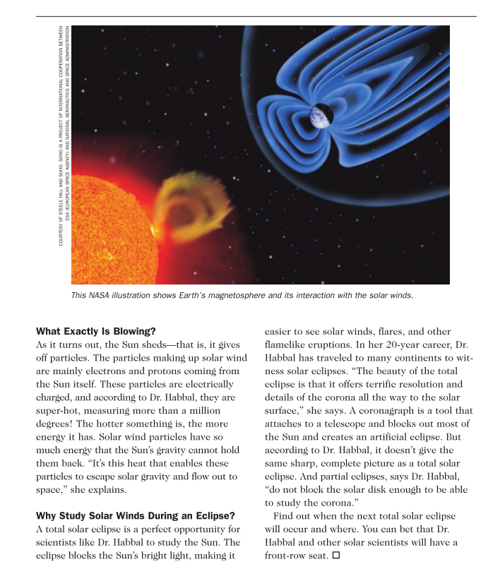

From STC/MS™ Earth in Space

