Independent Work Building a Barometer

Air pressure changes are related to changing weather conditions. In this lab, you will build and use your own barometer to measure air pressure.

Problem
How can a barometer detect changes in air pressure?

Materials
modeling clay white glue
pencil metric ruler
large rubber balloon drinking straw, 12–15 cm long
scissors cardboard strip, 10 cm × 25 cm
tape wide-mouthed glass jar
rubber band

Procedure Review the safety guidelines in Appendix A.
1. Cut off the narrow opening of the balloon.
2. Fold the edges of the balloon outward. Carefully stretch the balloon over the open end of the glass jar. Use a rubber band to hold the balloon on the rim of the glass jar.
3. Place a small amount of glue on the center of the balloon top. Attach one end of the straw to the glue. Allow the other end to extend several centimeters beyond the edge of the glass jar. This is your pointer.
4. While the glue dries, fold the cardboard strip lengthwise and draw a scale along the edge with marks 0.5 cm apart. Write “High pressure” at the top of your scale and “Low pressure” at the bottom.
5. After the glue dries, add a pea-sized piece of modeling clay to the end of the pointer. Place your barometer and its scale in a location that is as free from temperature changes as possible. Arrange the scale and the barometer as shown in the diagram in your textbook. Note that the pointer of the straw must just reach the cardboard strip.
6. Tape both the scale and the barometer to a surface so they do not move during your experiment.
7. In your notebook, make a data table, or use the one below. Record the date and time. Note the level of the straw on the cardboard strip.
8. Check the barometer twice a day. Record your observations in your data table.
9. Record the weather conditions for at least three days.

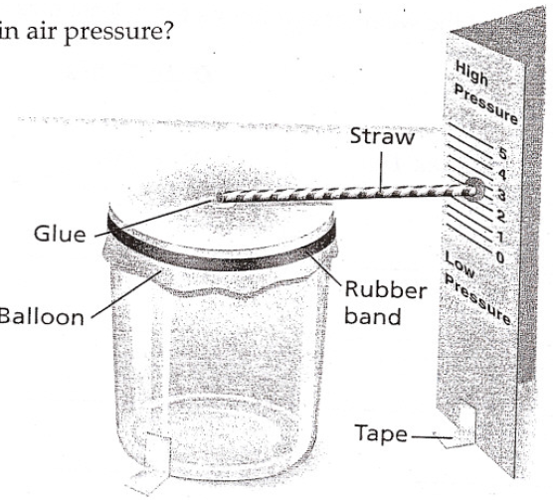

Name ________________________________________________________ Period _______

Complete and turn in this page with a picture of your barometer.

Table 1 Air Pressure and Weather Conditions
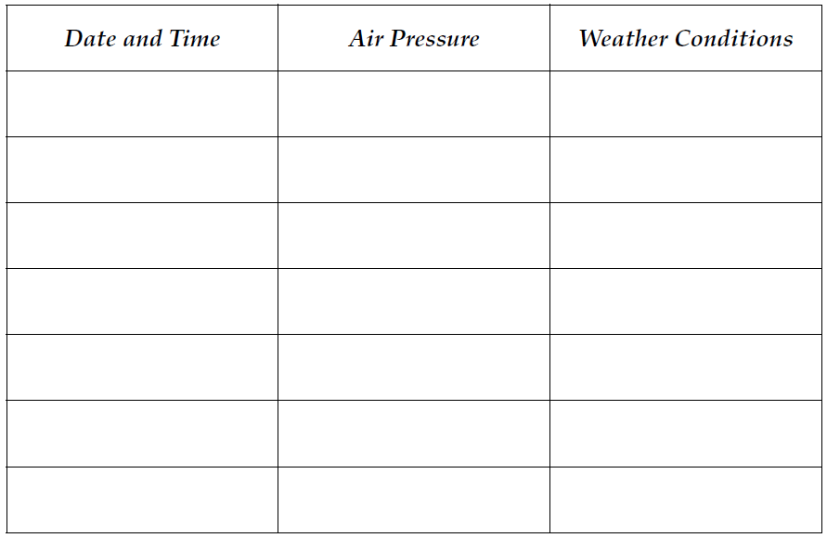

Analyze and Conclude (Does not need to be typed)

- Interpreting Data What change in atmospheric conditions must occur to cause the free end of the straw to rise? What change must occur for it to fall?

- Drawing Conclusions Based on your observations, what kind of weather is usually associated with high air pressure? With low air pressure?

3. More to Explore
Compare your pressure readings with high and low air pressure readings shown on newspaper weather maps during the same period. How do your readings compare with those in the newspapers?

