Name ____________________________________________________________ Period ________

Questions from Reading Chapter 15 Section 1. Pages 512 – 515

- What is Earth’s atmosphere? _______________________________________________________

_______________________________________________________________________________

- Label the larger pieces of the graph with the gases they represent:
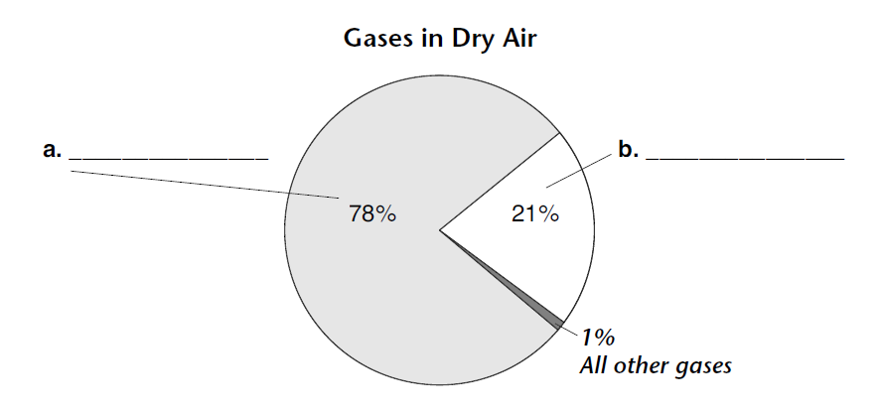
- What percentage of air is made of nitrogen and oxygen together? __________________________

- What is water vapor? _____________________________________________________________

- Why are the amounts of gases in the atmosphere usually shown as percentages of dry air?

_______________________________________________________________________________

_______________________________________________________________________________

- What are three ways in which the atmosphere is important to life on Earth? __________________

_______________________________________________________________________________

_______________________________________________________________________________

_______________________________________________________________________________

- What are two ways carbon dioxide is added to the atmosphere? ____________________________

_______________________________________________________________________________

