Independent Work 10 points Extra Credit
Chasing Andrew

Hurricanes are the most destructive storms on Earth. They develop from tropical storms (cyclones) and are classified as hurricanes when their winds reach 64 knots (about 71mph). Hurricanes include a small central region known as the eye, where the winds are light and there are few clouds. Moving out from the eye, a narrow band of intense thunderstorms, heavy rains and strong winds is encountered. This band is called the eye wall. The strongest winds of the storm are found in the eye wall. Beyond the eye wall are strong but diminishing spirals of the same weather. Hurricanes are huge storms. Typically they are about 300 miles in diameter, and they usually last for a week or more.
Hurricanes contain tremendous amounts of energy. They gather this energy from warm ocean waters in the tropics. As the warm, humid air rises, it cools and condenses, releasing heat (called latent heat). This heat warms the surrounding air, making it lighter and causing it to rise farther. As the warm air rises, cooler air flows in to replace it, causing wind. This cooler air is warmed by the ocean, and the cycle continues. The heat from warm ocean water is the fuel that hurricanes run on. For this reason, hurricanes diminish and die when they move inland or move into colder water.
In addition to high winds – gusts up to 192 mph – and torrential rains, hurricanes produce what is known as a storm surge. The circular winds together with the low-pressure eye and high-pressure outer regions of a hurricane create a mound of water in the center of a hurricane. The storm surge causes considerable flooding and is responsible for most hurricane damage and deaths.
Weather satellites in orbit above Earth can easily detect hurricanes. Satellite data, along with data from radar and aircraft, is used to follow developing hurricanes. Through tracking, we can tell where a hurricane has been. We can also estimate where it will go in the near future. When it appears that a hurricane is moving toward land, the National Weather Service (NWS) issues hurricane watches and warnings. A hurricane watch meant that hurricane conditions are likely in the area within 36 hours. A hurricane warning means that these conditions are likely within 24 hours. People living in low coastal areas that could be affected by a storm surge need to evacuate as soon as watches and warnings are issued.
In August 1992 Hurricane Andrew caused a tremendous amount of human suffering and billions of dollars of damage in the Bahamas, the southern tip of Florida, and parts of Louisiana. This hurricane was unusual because it struck the United States twice. After coming ashore in Florida, it passed over the Gulf of Mexico – regaining strength in the warm Gulf waters – then hit the coast of Louisiana. This activity contains the actual tracking data collected on Hurricane Andrew.

Procedure
- Look at the data in the different parts of the table marked “The Track of Hurricane Andrew”. It contains three types of information:
  - Date/Time: Data was collected on Andrew every 6 hours beginning August 16 through August 28. Only a portion of the data is presented here. Time in given in military convention; for example, 1200 is 12:00noon and 1800 is 6:00pm.
  - Position: This is the position of the eye of the hurricane by latitude and longitude. It is important to remember that the storm is much bigger than the eye. The winds extend out beyond the eye by about 60 miles in every direction (about ½ the area of one 5° longitude/latitude square on the map).
  - Wind speed: This is the maximum speed of the winds in the hurricane, not the speed with which the hurricane is actually moving. Wind speed is given in knots (kt). 1 kt = 1.15 mph.

- Plot the data given in the tracking table on the map. Make a dot for each position of Andrew, and then connect the dots. For each position, at the beginning of the day (time = 0000), draw a small star or asterisk over the dot.
- Answer “STOP! Question #1 – 5 in between the sets of data on the worksheet page.
- Answer questions 1 – 6 on the worksheet page.
- Turn in the worksheet and the map.

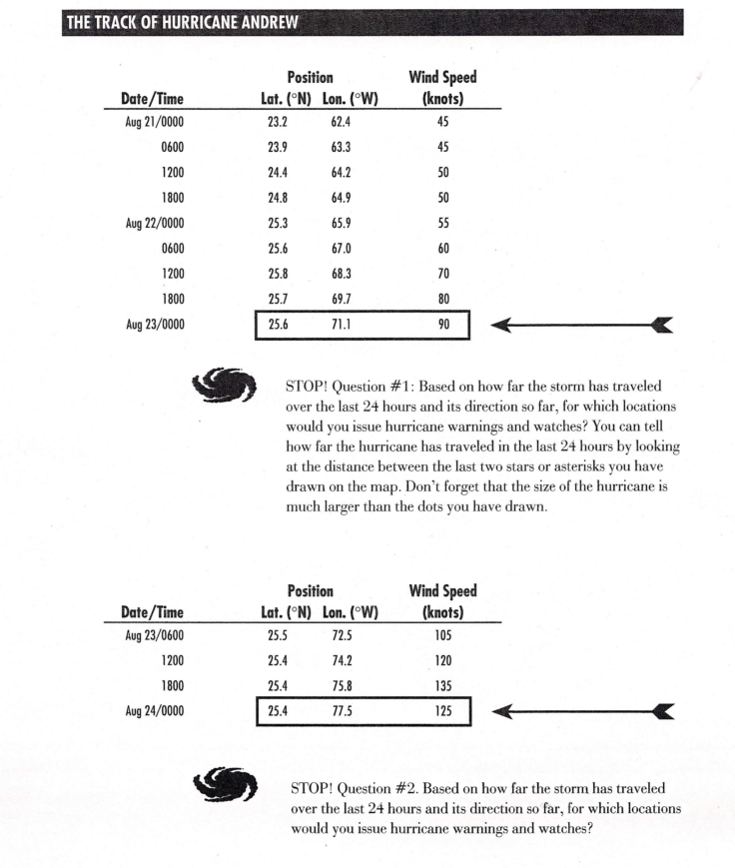

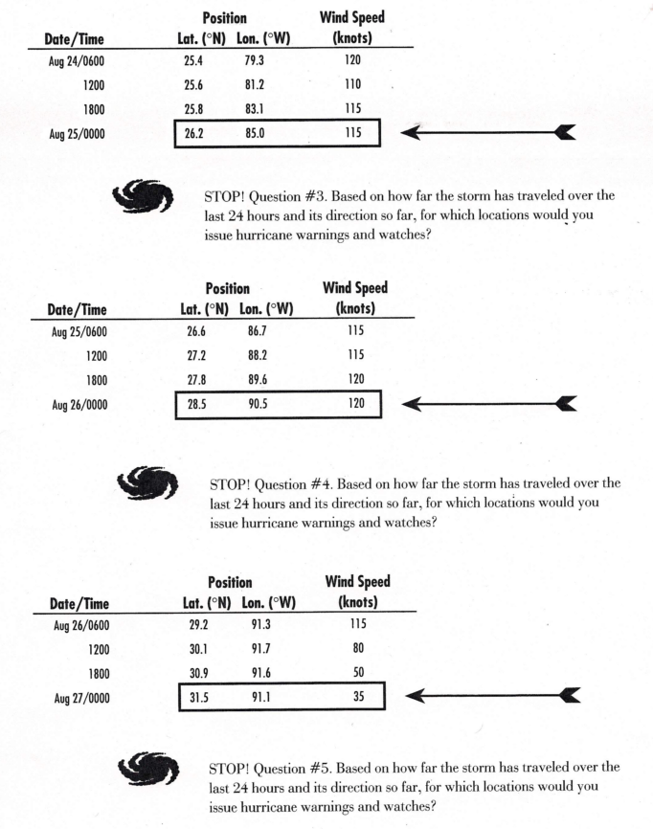
A Work Chasing Andrew

Name ________________________________________________________ Period _________

Worksheet

STOP! Question #1

STOP! Question #2

STOP! Question #3

STOP! Question #4

STOP! Question #5

QUESTIONS/CONCLUSIONS

- Where did Andrew do the most damage before striking Florida?

- Describe the direction (north, south, east, west) of motion of the storm displayed on your tracking map from the first point you plotted to the last. (Line up a straight edge between the first and last plotted points.)

- What happened to the direction of Andrew after it struck Louisiana? Why did this happen?

- What happened to the wind speed in Andrew after it came aground in Louisiana? Why did this happen?

- Judging from the wind speed, when did Andrew become a hurricane and when should it have been downgraded to a tropical storm?

- In terms of the damage done, why was it so devastating for Andrew to hit the southern part of Florida?

- Why might it have been less destructive if it had hit farther north on the coast of the United States; for instance, Georgia or South Carolina?

