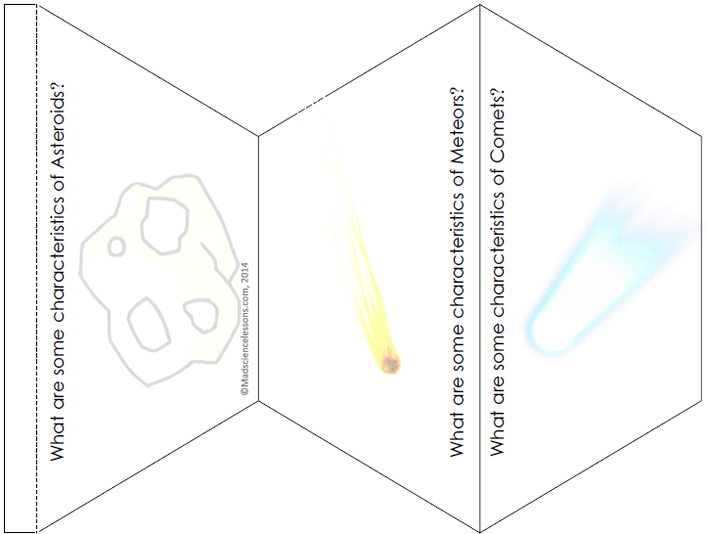

A chunk of ice and dust in a very elliptical orbit around the sun

Left over from when the solar system was created.

They come from the far edges of the solar system

Has two tails facing away from the sun

A chunk of rock or dust in space that orbits around the sun.

They are pieces of asteroids or pieces of planets blown into space by an asteroid collision.

A rocky object with an elliptical orbit around the sun that is too small to be a planet

Most come from the asteroid belt between Mars and Jupiter

Left over from when the solar system was created

Where would you find a meteoroid?

Where would you find a meteor?

Where would find a meteorite?

What are some characteristics of Meteoroids?

wWhh