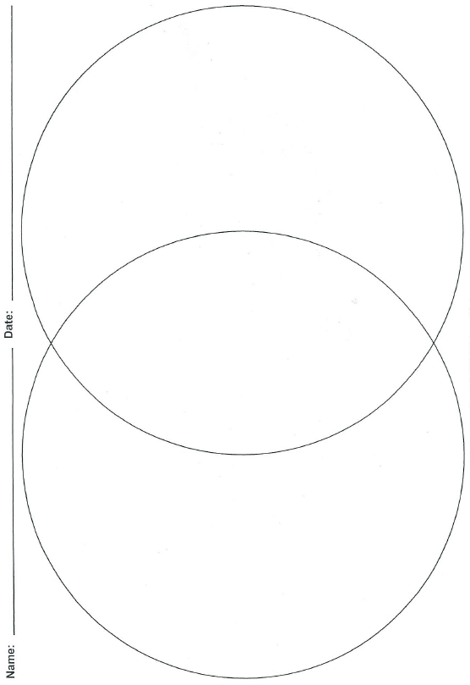

**Compare/Contrast**

**Tornadoes and Hurricanes**

**Both**

**Tornado**

**Hurricane**