Name _________________________________________________ Class____________

Independent Work: Contrails

Weather Factors
Contrails
Airplanes and jets release a lot of water vapor in the exhaust from their
engines. When aircraft fly at high altitudes where temperatures are low, the
water vapor condenses immediately into water droplets. These droplets
form a cloud that trails behind the plane. This cloud is called a contrail, or
condensation trail. When large numbers of contrails occur in an area, they
may blend together to form a sheet of cirrus clouds, although the contrails
evaporate quickly if the air is dry.
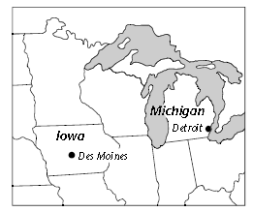
One area in which large numbers of contrails appear is the 860-kilometer
stretch between Detroit, Michigan, and Des Moines, Iowa. Every day, some
700 jet planes fly through the area between these two cities.

TYPE the answers to the following questions on a separate sheet of paper.
1. What can you infer about the height at which jet airplanes fly based on
the fact that their contrails form cirrus clouds? Explain.

2. Weather scientists believe that jet contrails between cities such as Detroit,
Michigan, and Des Moines, Iowa, may be changing the weather in these
areas. Explain how contrails could change the weather.

3. When a plane flies through a cloud, it sometimes leaves a clear trail called
a distrail, or dissipation trail. Why do you think distrails form? (Hint:
Plane engines get very hot and heat the air they fly through.)

