Name ___________________________________________________________________ Period __________
Convction Cells in the Atmosphere
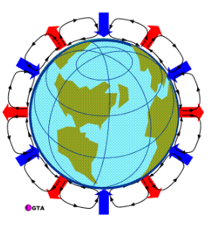

- Color the convection currents, red for hot air, blue for cold air.

- Color the arrow, red for hot air, blue for cold air.

- Label the long rectangles, H for high pressure, L for low pressure.

- What do the convection cells do for the planet?

