Name __________________________________________________________ Period ____________________
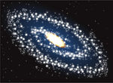
Type of Galaxy | Description | Illustration

