Answer Key
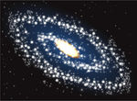
Type of Galaxy | Description | Illustration
Spiral | Looks like a pinwheel from above  Looks like a plate with a bulge from the side  Has middle age stars  Has a middle amount of free gas and dust | 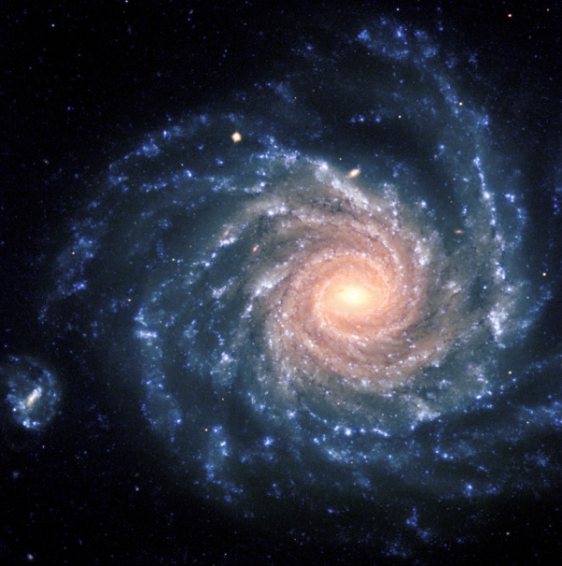
Elliptical | Range in shape from a perfect sphere to an oval  Contain some of the oldest stars in the universe  Has very little free gas and dust  This is the most common type of galaxy | 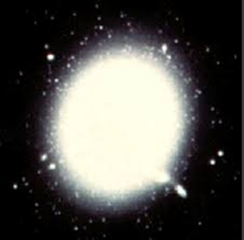
Irregular | A ‘none of the above’ category  Has newly forming stars and old stars  Has lots of free gas and dust | 