Name: _______________________________________________________________________ Period: ______________

**Analyzing Data: Gravity Versus Distance**

As a rocket leaves a planet’s surface, the force of gravity between the rocket and the planet changes. Use the graph to answer the questions below.

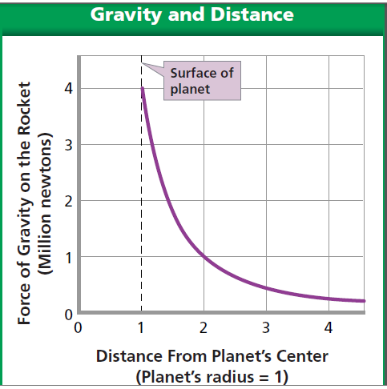

C:\Users\linda.barnes\AppData\Local\Microsoft\Windows\Temporary Internet Files\Content.IE5\0P6AYJIT\MC900326156[1].wmf

1. What two variables are being graphed? ___________________________________________________

____________________________________________________________________________________

1. In what units is each variable measured? __________________________________________________

____________________________________________________________________________________

1. What is the force of gravity on the rocket at the planet’s surface? ______________________________
2. What is the force of gravity on the rocket at a distance of two units (twice the planet’s radius from its center)? ________________________________________________________________________________________________________________________________________________________________________
3. In general, how does the force of gravity pulling on the rocket change as the distance between it and the planet increases? __________________________________________________________________