Independent Work Greenhouse Effect ***5 Points Extra Credit***
Instructions: Read the following article on the Greenhouse Effect and answer the questions at the end of the article.

When the Study of the Greenhouse Effect Began
The concern of the greenhouse effect and global warming is basically new to most people. Scientists have actually been studying the fact of the greenhouse effect since the 1800’s and the beginning of the Industrial Revolution. There were several men who were responsible for the discoveries which lead to the initial studies of the atmosphere, the gases in it, and the affect that it has on our planet.
- Jean Baptiste Joseph Fourier, a French mathematician and physicist studied how heat conducted through material. He was the first person that compared our atmosphere to that of a glass container.
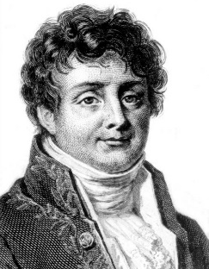
- John Tyndall, a British physicist, was the first scientist who studied radiant heat through gases. He discovered that nitrogen and oxygen – the main components in our atmosphere – were not effective in absorbing heat. His study titled “On Radiation through the Earth’s Atmosphere” published in 1863 detailed his observations on the absorption of heat by water vapor and carbon dioxide.
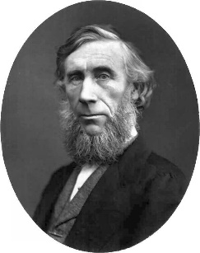
- Dr. Svante August Arrhenius, a Swedish chemist and Noble prizewinner, was responsible for advancing the understanding of the greenhouse effect. He was responsible for the discovery of the temperature increase calculation of up to 11°F due to carbon dioxide. Even though his study was conducted in 1896 his information was ignored for over 50 years.
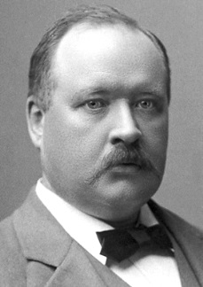
Dr. Svante August Arrhenius’ prediction in 1957 regarding the warming of our atmosphere was confirmed. Researchers noticed the carbon dioxide concentrations at the Hawaiian Volcano Mauna Loa were rising.
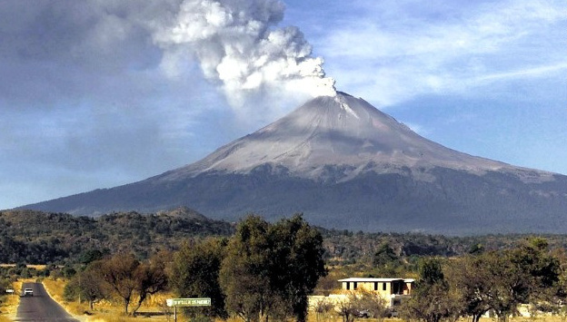
In 1957 carbon dioxide concentrations were recorded at 315 molecules of gas per million molecules (abbreviated ppm – parts per million). It was noticed during their research that the concentration levels were rising each year in 1970 – 323 ppm, 1980 - 335 ppm, and by 1988 - 350 ppm. When these numbers were analyzed it was noticed that there was a rise of 8% in carbon dioxide concentrations over 31 years.

With this confirmation in the rising concentrations of carbon dioxide, the interest in the build-up of greenhouse gases and their effect on our environment grew.

With the interest in global warming and the greenhouse effect growing, scientists worldwide keep an eye on the concentrations of greenhouse gases in the atmosphere. Atmosphere samples are gathered and analyzed and the levels of greenhouse gases are sent to other researchers. Scientists utilized this information in order to create models and scenarios how the Earth’s climate could change over the next 50 – 75 years. The sources of greenhouse emissions are automobiles, factories and power plants.
Instructions: Read the following article on the Greenhouse Effect and answer the questions at the end of the article.

Today’s Greenhouse Effect
The definition of the greenhouse effect is the capacity of certain gases in the atmosphere to trap heat emitted from Earth’s surface, thereby insulating and warming the planet. Without the thermal blanketing of the natural greenhouse effect, Earth’s climate would be about 59°F cooler – much too cold for most living organisms to survive.
Over the last 4 billion years the greenhouse effect has warmed the Earth. It is now becoming a concern for scientists where human activities may be adding to these gases and it may have dangerous effect. This warming effect is happening because of natural and human influences in the gases that prevent heat in the atmosphere from being released back out into space. Since the 1700’s, humans have led to the addition to the greenhouse gases with the use of burning wood, coal, oil and natural gas or what is known as fossil fuels. The burning of these fossil fuels is adding into the atmosphere carbon dioxide, methane, and nitrous oxide.
The increase in these gases are the cause behind what scientists are calling an unnatural heating effect and they have calculated that the overall temperature increase is just about 1°F and scientists believe that this is the warmest in the last 100 years. The effects of this warming trend are:
- The melting of Polar ice caps.
- The melting of glaciers.
- A possible rise in sea level.
- Possible flooding of coastal regions.
- Change in weather patterns.
- Prolonged droughts.

How the Greenhouse Effect Works
The greenhouse effect is the result of an interaction between sunlight and the atmosphere from the surface of the Earth to approximately 60 miles up. The composition of sunlight is a range of energies known as the solar spectrum that includes the following:

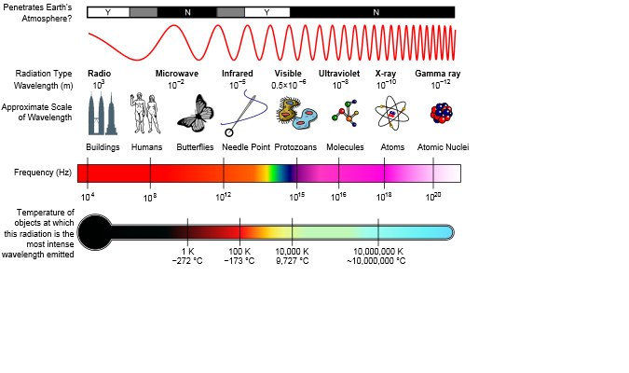
- Infrared light.
- Visible light.
- Ultraviolet light.
- X Rays.
- Gamma rays.
As the Sun’s energy reaches the atmosphere of the Earth approximately 25% of it is reflected back into space and approximately 20% is absorbed into the atmosphere. The absorption of this energy is absorbed the following ways:
- The gas molecules that are located in the upper atmospheric layers absorb the gamma and x rays.
- The ultraviolet radiation is absorbed by the ozone layer that is located from 12 -30 miles above the surface of the Earth.

The amount of Sun’s energy that does reach Earth is in the form of visible light. About half (50%) is absorbed in plants, soil and in the oceans as heat. The remaining 5% of the heat is reflected back into the atmosphere by sandy deserts, ice, and snow. The radiation that is absorbed by the Earth becomes heat energy and takes the shape of infrared radiation that is also released back into the atmosphere.
The gases in the atmosphere that absorb the heat energy from the Sun preventing it from being released back into space are water vapor, carbon dioxide, methane and nitrous oxide.
One of the reasons why these gases add to the warming of the Earth is that when warm the gases emit infrared radiation in all directions.
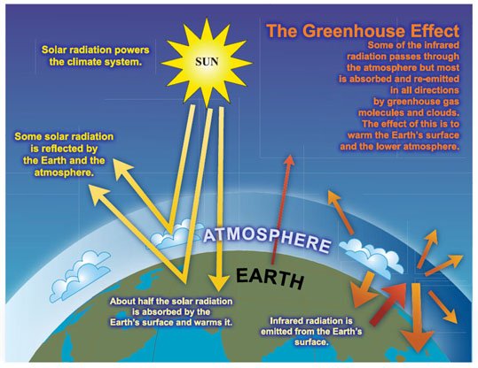
Infrared radiation is emitted in all directions one of the directions is of course back towards the earth that results in what is known as the greenhouse effect. Eventually some of this heat is released back into space. The heat energy received from the Sun and the heat energy released from the Earth create an equilibrium or energy balance. This equilibrium is important in maintaining the climate of Earth that supports such a variety of life.
The gases that cause the greenhouse effect are in fact gases that act like the glass in a horticultural greenhouse where they trap in the heat instead of letting it escape back into space.
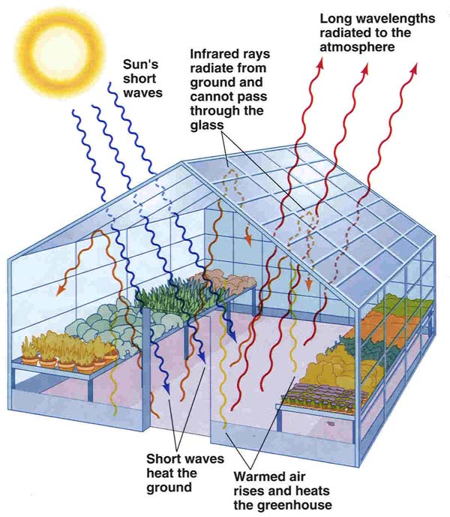
Very similar to the Earth’s atmosphere the glass roof of a horticultural greenhouse allows most of the light energy of the Sun to enter and does not allow a majority of the heat energy to escape. In this instance the inside of the horticulture greenhouse is warmer than the outside temperature. To appreciate our atmosphere and its importance in the maintenance of climate control it only takes a quick glance at the atmospheres of Mars and Venus. The atmosphere of Mars consists of 95% carbon dioxide, 3% nitrogen, 2% argon along with tiny amounts of oxygen, carbon monoxide, water vapor and ozone. In 2004 Methane gas was detected on Mars. This atmosphere is very thin and allows heat to escape causing the surface to be mostly frozen. On the other hand, the atmosphere on Venus is composed of 97% carbon dioxide and 3% nitrogen along with the intense cloud cover it maintains the heat energy that is received by the Sun. This heat energy in turn results in surface temperatures that average 854°F. The carbon dioxide in Venus’s atmosphere is very efficient gas that has been linked to “global warming” on earth.

Answer the Questions on the next page.

Name ______________________________________________________ Period ___________

Independent Work Greenhouse Effect ***5 Points Extra Credit***

- Without the thermal blanketing of the natural greenhouse effect Earth’s climate would be about ____________________________________.

- Complete the following sentence: Since the _______________________________________

- humans have led to the addition to the ______________________________________ with the

use of ________________________________, _____________________________, and

________________________________________.

- Complete the following sentence:
The burning of these fossil fuels are adding into the atmosphere

____________________________, ________________________________, and

_____________________________________.

- Name at least 4 of the effects of the warming trend that are affecting the Earth at this time:

1. _______________________________________________
2. _______________________________________________

3. _______________________________________________
4. _______________________________________________
- The composition of Sunlight is a range of energies known as the solar spectrum that includes the following:
1. _______________________________________________
2. _______________________________________________

3. _______________________________________________
4. _______________________________________________
- As the Sun’s energy reaches the atmosphere of the Earth how much is reflected back into space?

____________________________________________________________

- What is the amount of Sun’s energy that does reach Earth?

- ________________________________________________________________________________

- What is the amount of heat that is absorbed in plants, soil and oceans? ______________________

- What are the gases in the atmosphere that absorb the heat energy from the Sun preventing it from being released back into space?
1. _______________________________________________
2. _______________________________________________
3. _______________________________________________
4. ______________________________________________

- Explain how infrared radiation retains heat.
________________________________________________________________________________
________________________________________________________________________________
________________________________________________________________________________
________________________________________________________________________________
- What type of building simulates the greenhouse effect? Why?
________________________________________________________________________________

