Independent Work How Earth’s Atmosphere Got Its Oxygen
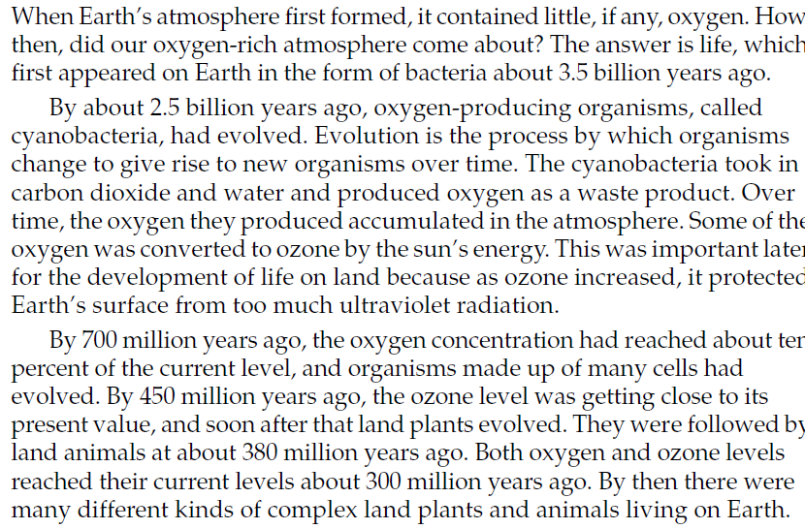
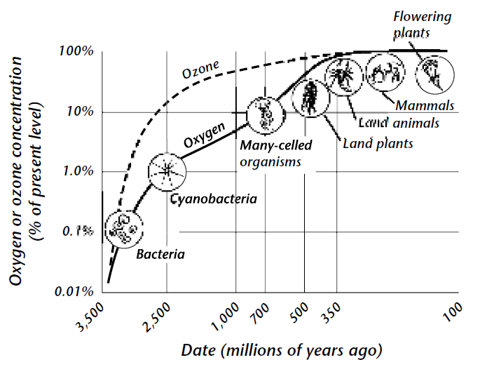
Answer the following questions on a separate piece of paper. Must be typed to be accepted.
- How did life on Earth influence the development of Earth’s atmosphere?

- What role did ozone play in the evolution of life on Earth?

- What do you think Earth’s atmosphere would be like today if life had not evolved on Earth?

