Name: _____________________________________________________________ Period: ___________
How Plates Move
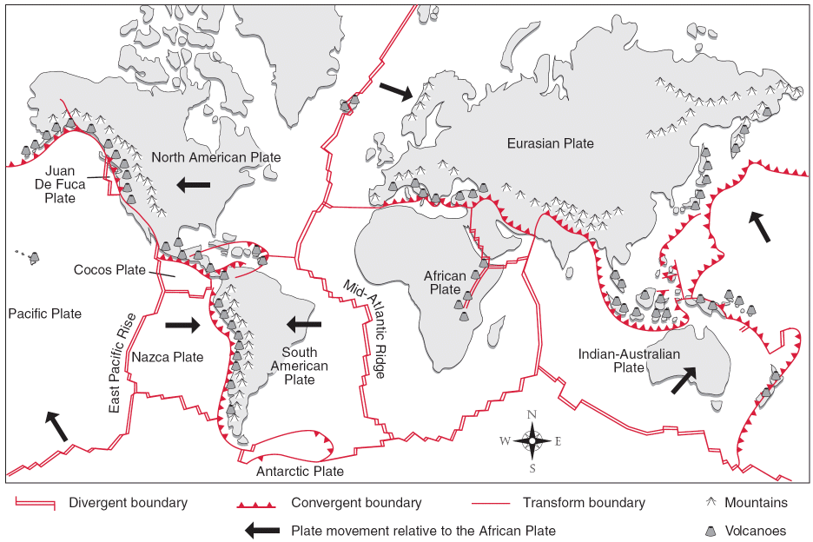
Directions: Refer to the diagram above to answer the following questions.
- What are the three types of plate boundaries?

- Using both words and arrows, describe the type of movement that occurs at each type of plate boundary.

- What will likely occur when two continental plates collide? On the map, circle a number 1 where you think this has occurred.

- What will likely occur at a plate boundary where oceanic crust collides with continental crust?

- In what direction is the part of the plate carrying Washington State moving?

- In what direction is the Pacific plate moving?

- As the North American plate and Juan de Fuca plate move, what type of plate boundary is between them?

- What features would you expect to occur at or near the boundary between the Juan de Fuca plate and the North American plate?

- As the Juan de Fuca plate and the Pacific plate move, what type of plate boundary is between them?

- What features would you expect to occur at or near the boundary between the Juan de Fuca plate and the Pacific plate?

- On the map, write and circle the number 2 where an island arc occurs. What kind of boundary is this? What kinds of crusts are involved?

- On the map, write and circle the number 3 where rifting is occurring on land. What features would you expect to find here?

- On the map, write and circle the number 4 where rifting is occurring under the ocean? What is this process called?

- Today, the Mediterranean Sea lies between Europe and Africa. But the African plate is moving toward the Eurasian plate at a rate of a few centimeters per year. Predict how this area will change in 100 million years. In your answer, first explain how the Mediterranean Sea will change. Then explain what will happen on land.

