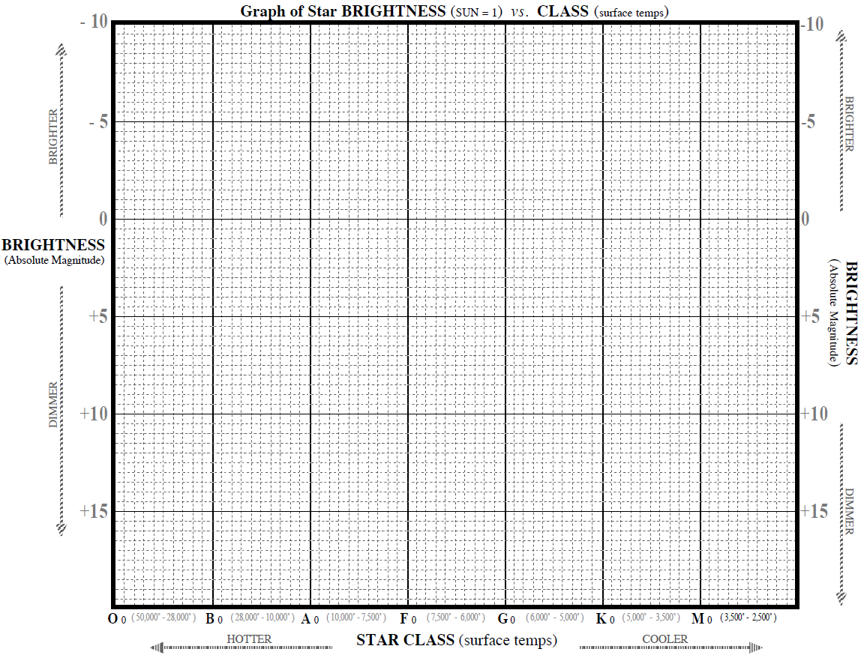

Name _____________________________________________________ Period __________