Independent Work
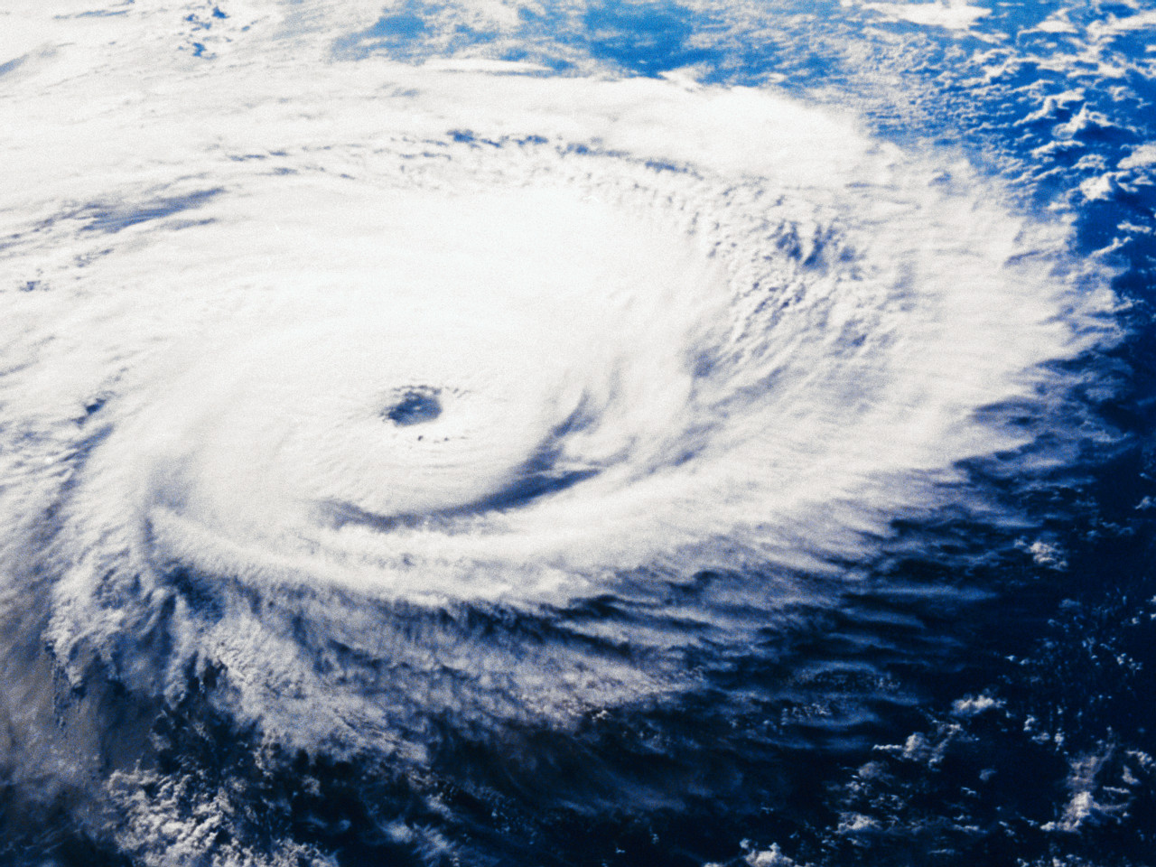

Hurricanes

You are a newspaper reporter sent to cover a hurricane about to strike the east coast of the country. Your editor wants you to describe all the events that you witness as the storm reaches the coast and begins to come ashore. Be sure to include detailed descriptions for your readers. Remember, a good reporter covers who, what, when, where, why and how.

LAYOUT  2 points | - Must be TYPED, 12 font and include HEADLINE and BYLINE. Must look like an actual newspaper article.
LEAD  3 points | - The lead is the first sentence in the article, and it gives the most important information to “hook” the reader’s attention.
BODY  10 points | - The body is the main part of the article, and it contains the five W’s  Who? What? Where? When? Why?  - Write three or four important details about the story.  - The article must be full of facts and unbiased.

Independent Work

Hurricanes

You are a newspaper reporter sent to cover a hurricane about to strike the east coast of the country. Your editor wants you to describe all the events that you witness as the storm reaches the coast and begins to come ashore. Be sure to include detailed descriptions for your readers. Remember, a good reporter covers who, what, when, where, why and how.

LAYOUT  2 points | - Must be TYPED, 12 font and include HEADLINE and BYLINE. Must look like an actual newspaper article.
LEAD  3 points | - The lead is the first sentence in the article, and it gives the most important information to “hook” the reader’s attention.
BODY  10 points | - The body is the main part of the article, and it contains the five W’s  Who? What? Where? When? Why?  - Write three or four important details about the story.  - The article must be full of facts and unbiased.

