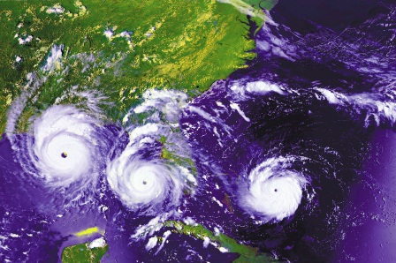
The Birth of a Monster
The air that surrounds our planet weighs 5,000,000,000,000,000 tons! In words, that is 5 quadrillion tons and that's a lot. This air is always moving. It swirls, blows, sinks, and rises. In summer and early fall, great masses of air sit over the warm, tropical oceans. If a mass of air gets warmer and picks up lots of moisture, it can start swirling. When this happens, a HURRICANE or a ONE-EYED MONSTER is born. If the hurricane moves toward the continent, it could wipe out everything in its path.

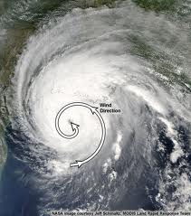
Hurricanes are tropical cyclones that can cover thousands of square miles. The winds in a hurricane exceed 74 miles per hour and circulate counter-clockwise about its center in the Northern Hemisphere or clockwise in the Southern Hemisphere. Hurricane-like storms are called by different names in the different regions of the world. Wind belts and highs and lows all help direct the journeys of tropical cyclones.

How does a "one-eyed monster" form? Actually, there are several ingredients needed for a hurricane to form.
- Tropical Ocean Water (at least 500 kilometers or 300 miles from the Equator)
- Heat from the Sun
- Air
- Wind
- The Spin of the Earth

Follow the steps below through the life cycle of a hurrricane.

A Monster is Born
Step 1. The sun warms the ocean water to 81 degrees Fahrenheit.
Step 2. The ocean water evaporates caused by the heat from the sun. The evaporating water forms a cloud of warm, moist air that moves upward.
Step 3. As the warm, moist air rises, more air rushes in to replace it. This air is also heated and moistened by the ocean surface. It begins to rise and form clouds, heating the air around it.
Step 4. Eventually, a large mass of warm, moist air with rain clouds is formed over the ocean. The warm air expands and becomes less dense and lighter and forms an area of low pressure.
Step 5. More warm, moist air rushes in from the ocean surface. The air begins to spin because of the rotation of the earth. The air goes faster and faster as it spirals inward.
Step 6. The whole storm, now spinning like a top, is carried across the ocean by the wind. As it moves across the warm ocean waters, it will continue to become stronger and stronger.
Step 7. Finally, it moves over land or cold water. It loses its fuel source, warm ocean, and begins to die out.

Hurricane Parts

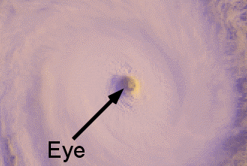
The EYE is located directly in the center of the hurricane. The average diameter of the eye is 20-40 miles across. Larger storms, such as typhoons in the Pacific, may have eyes as wide as 50 miles. The entire storm rotates around the eye. Inside the eye the wind is calm, the skies are clear, and the air pressure is very low.

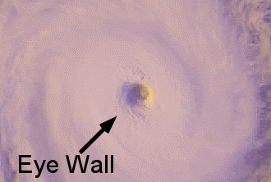
The EYE WALL surrounds the eye. It can be anywhere from 5-30 miles wide. The most damaging winds and heaviest rains are found in the eye wall.

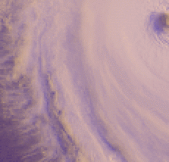
RAIN BANDS are a series of dense clouds that form a spiral around the eye wall. They give the hurricane a pinwheel appearance. These dense bands of thunderstorms spiral slowly counterclockwise. They range in width from a few miles to tens of miles and are 50 to 300 miles long. Sometimes the bands and the eye are hidden by higher level clouds. This makes it difficult for forecasters to use satellite imagery to monitor the storm.

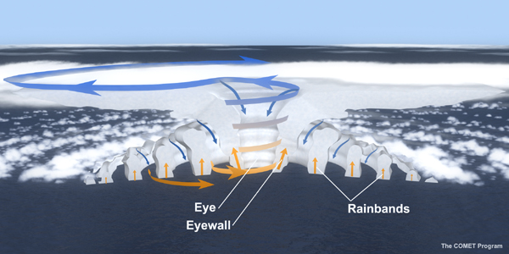

Hurricane Stages
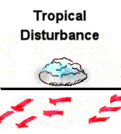
A TROPICAL DISTURBANCE is the first stage of development of a hurricane. It consists of a mass of thunderstorms that have only a slight wind circulation. The tropical disturbance becomes a tropical depression when the winds increase to more than 23 miles per hour.

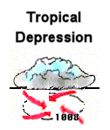
A TROPICAL DEPRESSION forms when a group of thunderstorms comes together under the right atmospheric conditions for a certain length of time. Winds near the center of the tropical depression are constantly between 23-39 mph. Lowered pressure is indicated with at least one closed isobar on a surface pressure chart. Also, the organized circulation of wind in the center of the thunderstorms is detected.
This is a satellite picture of a tropical depression. 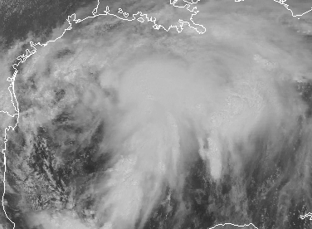
Tropical depressions look like individual thunderstorms that are grouped together.

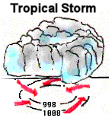
A TROPICAL STORM forms when the maximum sustained winds have intensified to between 39-73 mph. It becomes better organized and begins to look like a hurricane with a circular shape. At this point, the storm is given a name. Most of the problems from tropical storms come from heavy rainfall.

This is a satellite picture of tropical storm Charlie in 1998 over Texas. This storm dumped between 5-10 inches of rain over many southern Texas cities. | 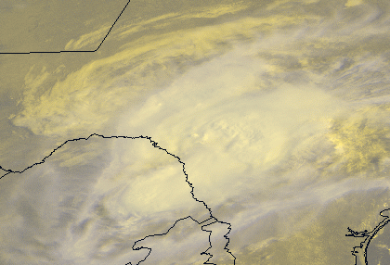
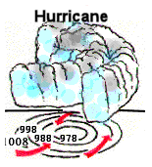
A HURRICANE finally forms when surface pressures continue to drop and when sustained wind speeds reach 74 mph. There is also a definite rotation about the eye.

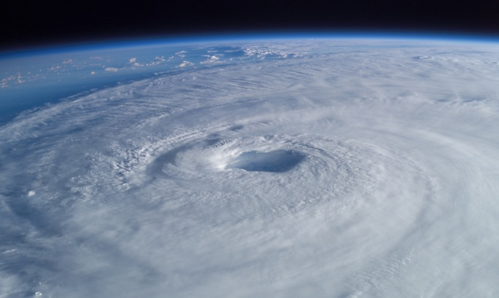

Hurricane Tracking
The National Weather Service knows about a hurricane long before it reaches land. Satellites are constantly taking pictures of any weather disturbances. When a hurricane is spotted, hurricane hunter airplanes fly into the storm and report on it. As it comes closer to land, special weather radars track it. Radio, television, and more than 300 NOAA Weather Radio stations warn people about the hurricane. It is a big responsibility of the National Weather Service to make accurate observations so that they can warn people about an approaching hurricane. The National Hurricane Center issues a series of warnings to specific areas of coastline as a hurricane speeds closer to land.

You can track a hurricane using latitude and longitude. Download a hurricane tracking map from the National Hurricane Center. Listen to the radio or television for the latest coordinates. They are updated each hour. You will be able to trace the path of the hurricane as it moves towards land.

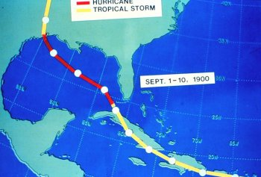
If you had been around in 1900 when the deadliest hurricane in history struck Galveston, your track would have looked something like this. At that time there were no weather satellites or Doppler radar. However, people were advised to seek higher ground by the U.S. Weather Bureau. Unfortunately, many folks didn't take the warnings seriously. They thought it would be fun to watch the huge waves.

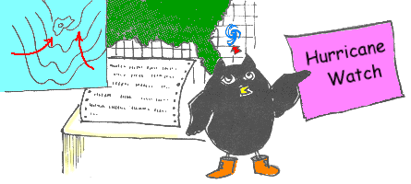
Today, a HURRICANE WATCH is issued when weather forecasters determine that you could experience hurricane conditions within 36 hours. A Hurricane Watch alerts people along the coast so that they can evacuate. It is important to keep listening to the radio or television for weather advisories from the National Weather Service.

WHAT TO DO IF A HURRICANE WATCH IS ISSUED
- Check often for official bulletins on your local radio or television.
- Fuel your car.
- Check mobile home tie downs.
- Move boats to safe shelter.
- Make sure you have the items in your Disaster Supply Kit.
- Secure lawn furniture and other loose material outdoors.
- Shutter or board windows. If neither are available, tape windows.
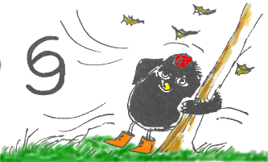
Winds in a hurricane will blow at least 74 miles an hour. A HURRICANE WARNING is issued when dangerous high water and very rough seas are expected within 24 hours. Once this warning has been issued, your family should be in the process of completing protective actions and deciding the safest location to be during the storm.

WHAT TO DO IF A HURRICANE WARNING IS ISSUED
- Stay tuned to your local radio or television station.
- Stay home if sturdy and on high ground.
- Board up garage and porch doors.
- Move valuables to upper floors.
- Bring in your pets.
- Fill containers with drinking water.
- Turn up refrigerator to maximum cool. Do not open unless necessary.
- Use phone only if necessary.
WHAT TO DO DURING THE STORM
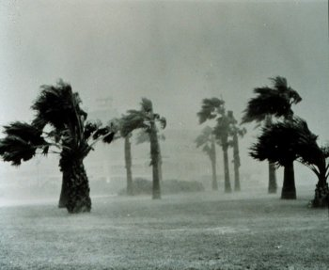
- If you're not ordered to evacuate, get into a safe room away from windows.
- If electricity goes out, use flashlights� candles can start fires.
- Do not cook during the storm. A gust of wind could spread a fire and the fire department would not be able to help you!
- BEWARE OF THE EYE OF THE STORM. Rain and wind may stop for a few minutes to a half hour. DON'T BE FOOLED. Rain and winds can suddenly pick up from the opposite direction.

- WHAT TO DO AFTER THE STORM
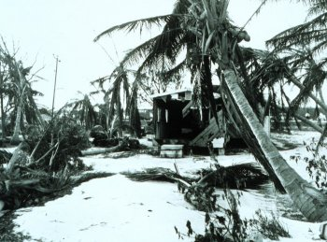
- Tune in to your local news on a battery-operated radio or television for the latest information.
- Wait for the "all clear" before venturing outdoors.
- Stay away from dangling power lines.
- Report broken or damaged water, sewer or electrical lines to proper authorities.
- Use only water that has been stored in bottles or declared safe by public officials.
- Don't eat food opened or contaminated in any way by the storm.
- Make temporary repairs as soon as possible to keep further damage from occurring.
- Notify your insurance company immediately of property damage.
- Be patient! Local, state and federal officials will work around the clock to help residents with cleanup.

Hurricane Categories
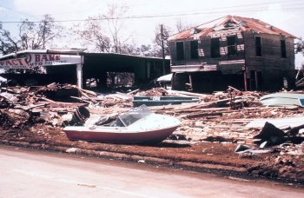
Hurricane intensity is measured using the Saffir-Simpson damage potential scale. It is named after Herbert Saffir, a consulting engineer in Coral Gables, Florida, and Robert Simpson, who was director of the National Hurricane Center from 1967 through 1973. Mr. Saffir developed the first version of the scale in 1971 for a United Nations report on construction that could stand up to high winds. It used wind speeds as a guide to the damage to expect. Hurricane Camille that hit the Mississippi Coast on August 17, 1969, was the reason the scale was devised. On the Saffir-Simpson scale hurricanes are rated by their potential for damage on a scale of one to five.

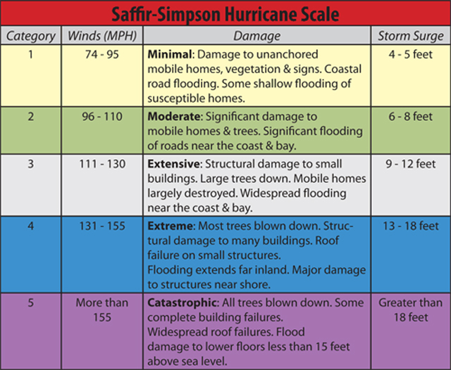

View each photo and rank the hurricane damage using the
Saffir-Simpson Hurricane Scale
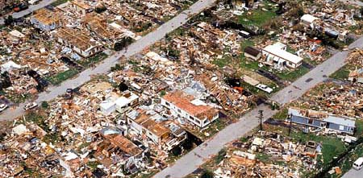
Hurricane Andrew, 1992
Unlike many hurricanes, Andrew caused more damage from its winds than its storm surge. Andrew destroyed or damaged more than 200,000 homes and businesses. It left more than 160,000 people homeless. One million people in Florida and 1.7 million in Louisiana and Mississippi were evacuated for their homes.

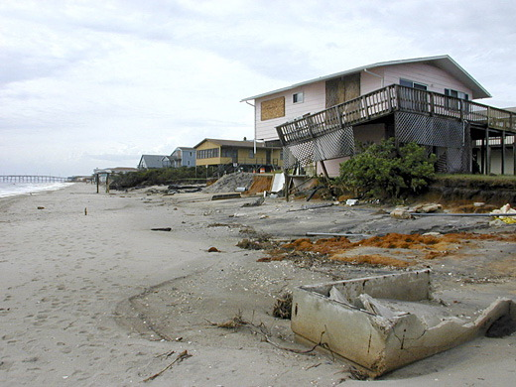
Hurricane Floyd, 1999
With a death toll of 57, Hurricane Floyd was the deadliest United States hurricane since Hurricane Agnes in 1972. The storm also was one of the costliest in the nation's history, amounting to $4.5 billion (1999 USD; $5.3 billion in 2006 U.S. dollars). Most of the deaths and damage were from inland, freshwater flooding in eastern North Carolina.

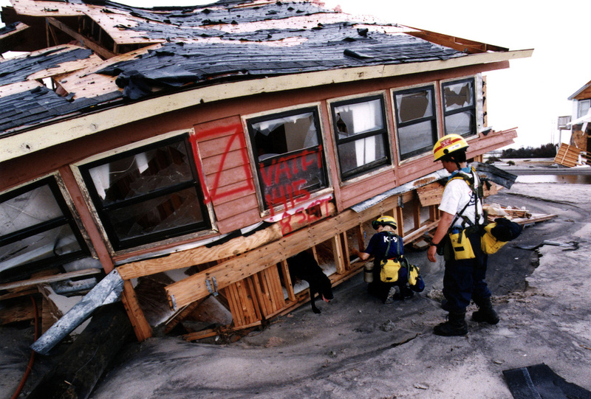
Hurricane Fran, 1996
The most severe damage took place in North Carolina where 14 people died, one of which was from a heart attack, and the storm left $2.4 billion in losses. Throughout other states, 13 other people lost their lives and an additional $800 million in damage was caused. Overall, Hurricane Fran was directly responsible for 22 fatalities and indirectly for five others as well as $3.2 billion in damage. At the time, Fran was one of the ten costliest hurricanes to strike the United States; however, several other storms have since surpassed it.

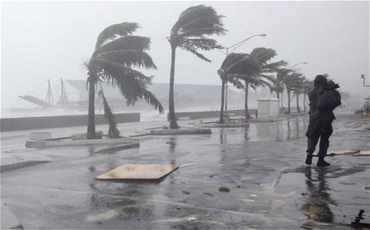
Hurricane Irene, 1999
Irene killed 18 people (15 indirectly) and caused $800 million ($937 million 2006 USD) in damage. Most of the damage and deaths occurred due to the torrential rain the storm caused.
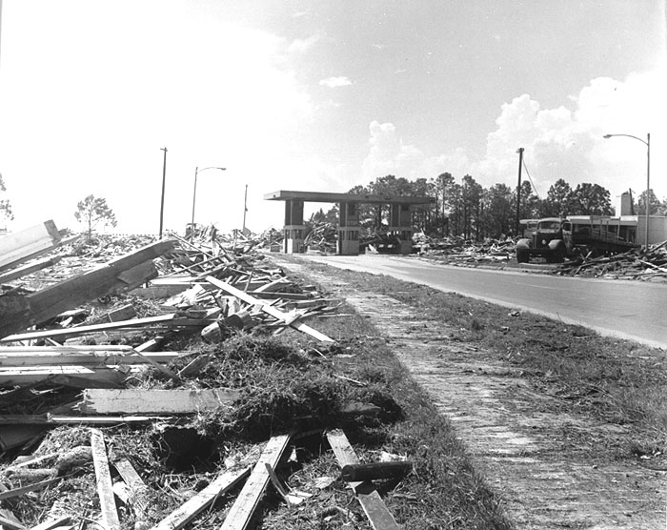
Hurricane Camille, 1969
Camille caused damage and destruction across much of the Gulf Coast of the United States. Because it moved quickly through the region, Hurricane Camille dropped only moderate precipitation in most areas. The area of total destruction in Mississippi was 68 square miles. The total estimated cost of damage was $1.42 billion ($9 billion 2013 USD). This made Camille the second-most expensive hurricane in the United States, up to that point. The storm directly killed 143 people along Alabama, Mississippi, and Louisiana. An additional 153 people perished as a result of catastrophic flooding in Virginia and other areas nearby. In all, 8,931 people were injured, 5,662 homes were destroyed, and 13,915 homes experienced major damage, with many of the fatalities being coastal residents who had refused to evacuate.

Effects of a Hurricane
HURRICANE EFFECTS can create major problems. The maximum effects of a hurricane are usually felt within the right-front quadrant. Here the winds are usually the strongest, storm surge is highest, and the possibility of tornadoes is greatest. It is important to know whether or not your area will be affected by the right-front quadrant. It could mean the difference between maximum hurricane conditions or a glancing blow.

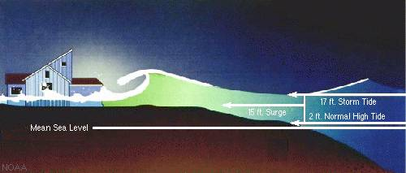
STORM SURGE is the fast uprising of sea level that happens when a hurricane approaches the coast. Two factors that cause storm surge are:
- Strong winds that push the water toward the coast and
- Suction created by the storm's low pressure.
Galveston Island on the Texas coast has suffered much damage due to hurricane-caused storm surges. A large sea wall has been built to help reduce the damage caused by the surges. The frequent occurrence of storm surges has also played a part in the destruction of Highway 87 along the Texas coast, which was used by many local beach-goers.

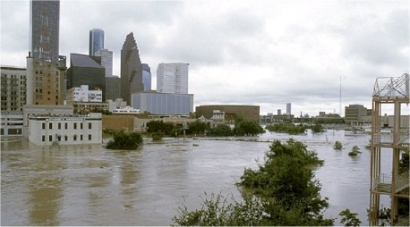
HEAVY RAINFALL is produced by hurricanes. The amount of rainfall usually varies between 6 and 12 inches. The most deadly rainfall occurs inland because a hurricane produces destructive floods. The flooding is the major cause of hurricane-related deaths. The danger from flooding depends on the storm's speed, other weather systems in the same area, the ground saturation, and the terrain.
Rains are heaviest in the six hours before and the six hours after the hurricane reaches landfall. Sometimes a hurricane can last for days and produce floods. These floods can occur more than 100 miles inland. One way to estimate the total inches of rainfall is to divide 100 by the forward speed of the hurricane in miles per hour.
Sometimes the remnants of the hurricane may join with other storm systems causing severe rainfall in states far away from where the hurricane came inland. Hurricane Camille in 1969 came into the Gulf Coast area, but the remnants combined with a cold front in the mountains of Virginia and produced 30 inches of rain. This storm also killed 109 people.
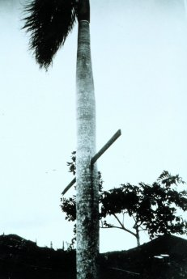
HIGH WINDS is another effect of hurricanes. The wind speed and potential damage of a hurricane is expressed as categories according to the Saffir-Simpson Hurricane Scale.
These high winds can easily destroy homes and buildings. Debris, such as signs or broken materials, can become airborne and penetrate just about anything with missile-like force.

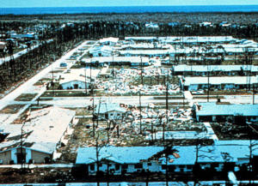
TORNADOES are often produced by hurricanes. Even though the tornadoes most likely form in the right-front quadrant of the hurricane, they can appear elsewhere. Some hurricanes develop several tornadoes, while others create none at all. During Hurricane Beulah in 1967, 141 tornadoes developed on the Texas coast. It is true, though, that more than one-half of hurricanes that make landfall will develop at least one tornado. There is no way to predict which hurricanes will produce tornadoes. Generally, tornadoes do not occur with hail or a lot of lightning. If a low pressure system remains for days after landfall, tornadoes can still develop. However, after twelve hours, they tend to appear mainly during the day.
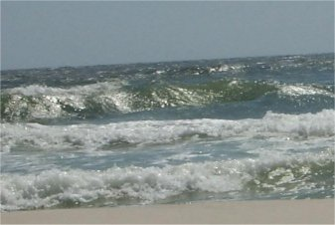
RIP TIDES are another effect of hurricanes. Rip tides are strong sea currents. They push away from the shore as a strong storm is near. Rip tide warnings are often the first indication of a nearby hurricane. They are formed by the strong winds pushing water towards the shore. The wind of a tropical cyclone can push waves up against the shoreline even if it is hundreds of miles away.

Hurricane Preparation

HURRICANE PREPARATION is serious business especially if you live in a "hurricane zone". Before hurricane season begins, these are some things that you need to do in case a hurricane heads your way.

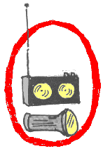
You need to always have plenty of water because the water sources may be shut off. You also need to have can goods to last you for two weeks. Be sure that you have a hand-held can opener. A battery-operated radio, batteries of all sizes, flashlights, and a first-aid kit are necessities also.
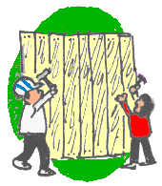
If you know for sure that a hurricane is heading your way, try to board up your windows. Stay indoors until it is completely over. Also, put sandbags outside your home to help prevent flooding. Stay tuned to your local stations or NOAA Weather Radio.

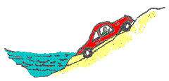
If you have to leave your home, pack what you need. Follow your town's evacuation route. Stay away until it is safe to return. Don't forget your pets. Have a collar and leash for them and a cage if possible.
"FIVE BASIC HURRICANE SAFETY ACTIONS"
- Know if you live in an evacuation area. Know your home's vulnerability to storm surge, flooding and wind. Have a written plan based on this knowledge.
- At the beginning of hurricane season, check your supplies, replace batteries and use food stocks on a rotating basis.
- During hurricane season, monitor the tropics. Monitor NOAA Weather Radio.
- If a storm threatens, heed the advice from local authorities. Evacuate if ordered.
- Execute your family plan.
Hurricanes
Hurricanes and their close relatives, typhoons and cyclones, are formed in the same way. They are not the normal storms created when cold and warm fronts collide.
The illustration below describes the process of how a hurricane forms.

How do Hurricanes Get Their Names?
Short, distinctive names for hurricanes in written and spoken communications are quicker and less likely to be mistaken, unlike older more cumbersome latitude-longitude identification methods. Since 1953, Atlantic tropical storms have been named from lists made up by the National hurricane Center. These are now maintained and updated by an international committee of the World Meteorological Organization. The naming of the storms began in the 1950’s and featured only women’s names until 1979, when men’s and women’s names were alternated. Six lists are used in rotation.
The only time that there is a change in a name on the list is if a storm is so deadly or costly that the future use of its name on a different storm would bring back bad memories. That storm’s name is removed from the list and another name is selected to replace it. Some of the Atlantic storms which will never be used again and the year they occurred are: Andrew, 1992; Carmen, 1974; Gilbert, 1988; Hugo, 1989; Klaus, 1990; Mitch, 1998.
2012 | 2013 | 2014
Alberto  Beryl  Chris  Debby  Ernesto  Florence  Gordon  Helene  Isaac  Joyce  Kirk  Leslie  Michael  Nadine  Oscar  Patty  Rafael  Sandy  Tony  Valerie  William | Andrea  Barry  Chantal  Dorian  Erin  Fernand  Gabrielle  Humberto  Ingrid  Jerry  Karen  Lorenzo  Melissa  Nestor  Olga  Pablo  Rebekah  Sebastien  Tanya  Van  Wendy | Arthur  Bertha  Cristobal  Dolly  Edouard  Fay  Gonzalo  Hanna  Isaias  Josephine  Kyle  Laura  Marco  Nana  Omar  Paulette  Rene  Sally  Teddy  Vicky  Wilfred
Do you see your name on the lists?

Cruise ’n for a Bruise ’n
Hurricanes are weather’s greatest storms and are the biggest threat to life and property in the United States. Already, hurricane science has much improved in the last several years, but in two important ways, the threat has gown bigger rather than smaller.
  - A new long-term trend toward more hurricanes seems to have kicked in. The U.S. can expect more hurricanes each season.
  - The country has made itself more vulnerable in recent years. People tend to move their homes and businesses into the paths of hurricanes.
Also, the time that it takes to evacuate some crowded coastal communities is longer than the time for which accurate hurricane forecasts can be made.
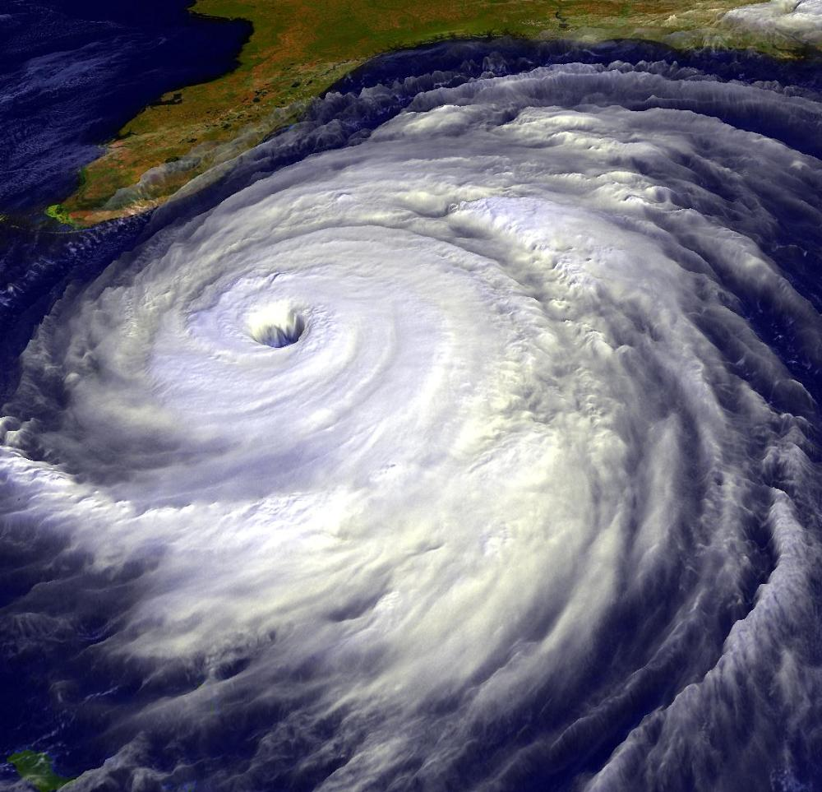
The following are tools forecasters and researchers are using to try to figure out these great storms.
While the hurricanes are still far out at sea, forecasters rely on direct observations from ships and instruments on ocean buoys. Satellites are their main toll and can orbit 22,000 miles above the equator at the same rate as the earth’s daily rotation, so always they hover over the same patch of the planet. Their big picture images allow forecasters to track storms night and day all over the Atlantic Ocean. These images are the first important clues to the formation of these storms as well as their location, size and intensity.

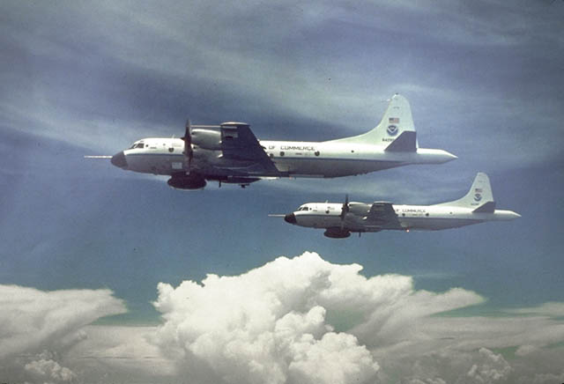
As the storms move closer to land, direct measurements are made by “Hurricane Hunter” airplanes.
Routinely, the US Air Force Reserve uses a specially equipped flight of C-130 aircraft to monitor approaching hurricanes. Their pilots fly into the core of the storm. Specialists aboard these planes drip instrument packages through the storms that radio back accurate information about the location of its eye, the strength of its winds, the direction and pace of its progress, and other important features such as air pressure, temperature, and humidity.
The National Oceanic and Atmospheric Administration (NOAA) also have two special hurricane-probing planes, including a high altitude jet, that are designed for research.

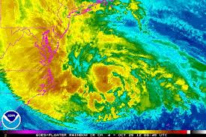
As the storms get within about 200 miles off of the coastline, land-based weather radar begins to give forecasters important indirect measurements. The new Doppler Radars give forecasters valuable images that give details about the internal structure of the storm – its wind fields, and how they change as a hurricane approaches land.

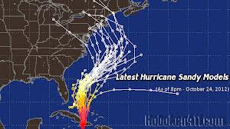
Forecasters are increasingly relying on computer models to help them forecast the intensity of the hurricane and its movement. Detailed information from all of the satellite sensors, and aircraft instruments, radars, ships and buoys continuously pours into the computer models. The results of a whole group of forecasting models are compared with one another as hurricanes approach the coast.

