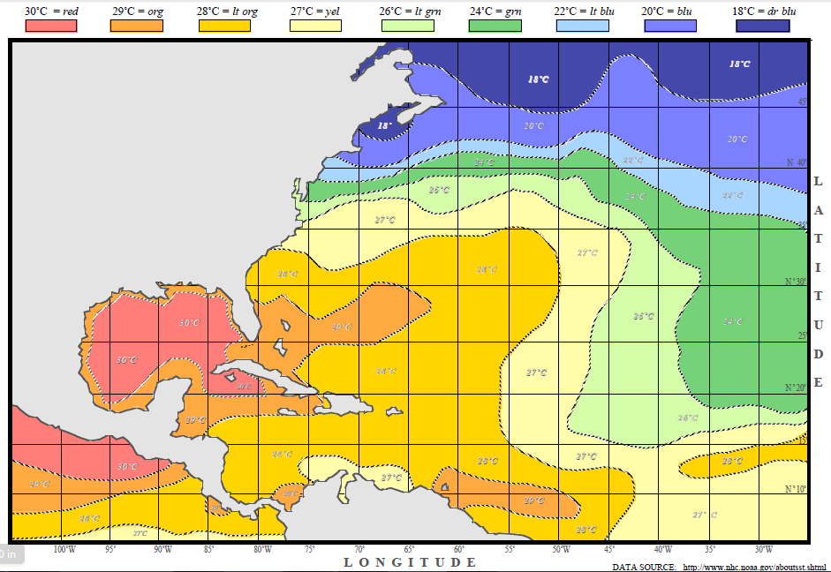

**Hurricane Waters**

**Mid-August 2009**

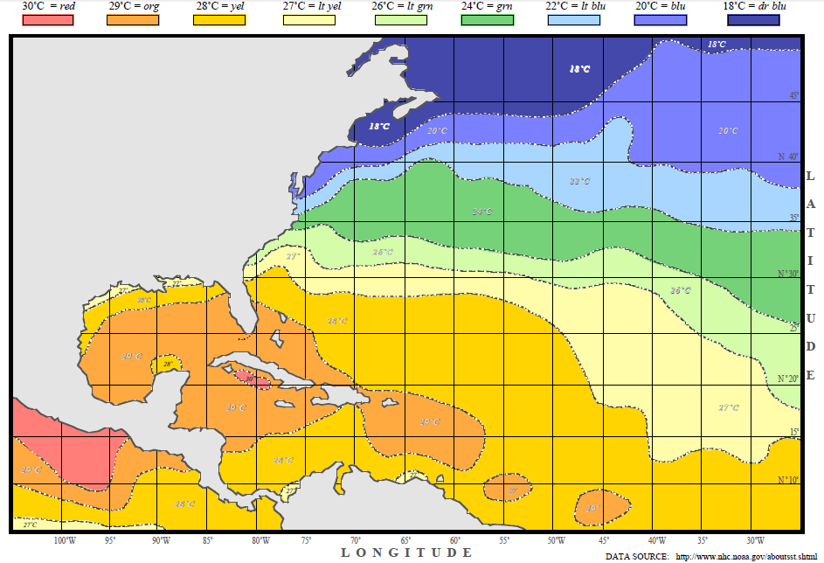

**Hurricane Waters**

**Mid-October 2009**

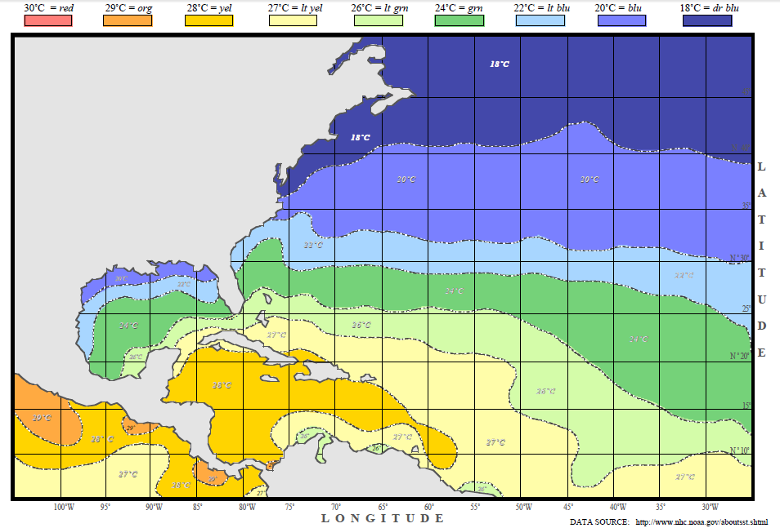

**Hurricane Waters**

**Mid-December 2009**