Name ________________________________________________________ Period _______
Investigating Lunar and Solar Eclipses
Procedure:
- Model a full moon using the large white 7.5 cm sphere (the Moon), a flashlight (the Sun), and you (the Earth).
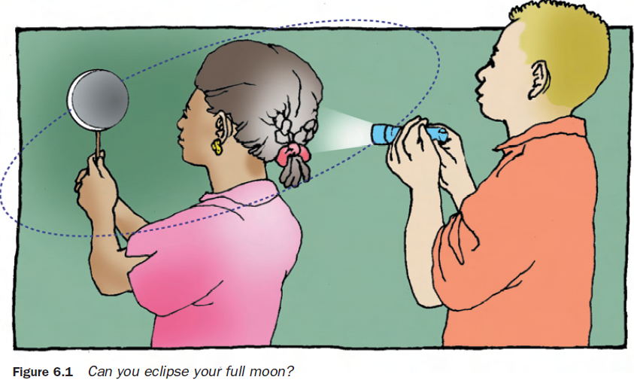
- Model the conditions under which a full moon is totally eclipsed (its light is blocked), as shown in figure 6.1. Share roles with your groups so that everyone has a chance to model Earth. What is casting the shadow on the Moon?

- Draw this type of eclipse in the box below. Label the Moon, Sun and Earth in your illustration. Draw the shadow. Write a sentence that describes your drawing.

Sentence:

- Now model conditions under which a full moon is partially eclipsed (its light is only partially blocked). Where does the shadow fall on the Moon?

- Draw this type of eclipse in the box below. Label the Moon, Sun and Earth in your illustration. Draw the shadow. Write a sentence that describes your drawing.

Sentence:

- Model a new moon using your sphere (the Moon), flashlight (the Sun) and yourself (the Earth).

- Model the conditions under which a new moon can totally eclipse the Sun’s light. Have your partner examine the shadow cast by the new moon. Where does the shadow fall?

- Draw this type of eclipse in the box below. Label the Moon, Sun and Earth in your illustration. Draw the shadow. Write a sentence that describes your drawing.

Sentence:

- Again, model a new moon eclipsing the Sun’s light, but this time increase the distance between your head (Earth) and the sphere (new moon). What happens to the shadow cast by the new moon? Where does the shadow fall?

- Draw this type of eclipse in the box below. Label the Moon, Sun and Earth in your illustration. Draw the shadow. Write a sentence that describes your drawing.

Sentence:

Table 6.1 Full Moon, New Moon, Lunar Eclipse and Solar Eclipses School Year 2013-2014 (*Eclipse)
Full Moon | New Moon | Type of Eclipse | Where Seen
11/17/2013 | 11/3/2014* | Solar Eclipse  Hybrid: (Annular – Total) | Easter N. America and E. South America,  S. Europe, Africa
12/17/2013 | 12/3/2014
1/16/2014 | 1/1/2014
2/14/2014 | 1/30/2014
3/16/2014 | 3/30/2014
4/15/2014* | 4/29/2014* | Annular Solar  Total Lunar | Australia, Antarctica  Everywhere (night side)
5/14/2014 | 5/28/2014
6/13/2014 | 6/27/2014
10/8/2014* | 10/23/2014* | Partial Solar  Total Lunar | N. Pacific, N. America  Everywhere (night side)

Directions: Use the information in Table 6.1 and your observations from investigating Lunar and Solar Eclipses to answer the following questions.

- During what phase does a lunar eclipse occur? Give one date as an example. _______________

______________________________________________________________________________

- During what phase does a solar eclipse occur? Give one date as an example. _______________

______________________________________________________________________________

- Did an eclipse occur with each full and new moon? EXPLAIN __________________________

______________________________________________________________________________

______________________________________________________________________________

______________________________________________________________________________

- Do lunar and solar eclipses occur in the within the same 30 day period? Explain why or why not. _________________________________________________________________________

______________________________________________________________________________

______________________________________________________________________________

- Under what conditions does a total solar eclipse occur? ________________________________

______________________________________________________________________________

______________________________________________________________________________

- Under what conditions does a partial solar eclipse occur? ______________________________

______________________________________________________________________________

______________________________________________________________________________

- Under what conditions does an annular solar eclipse occur? ____________________________

______________________________________________________________________________

______________________________________________________________________________

