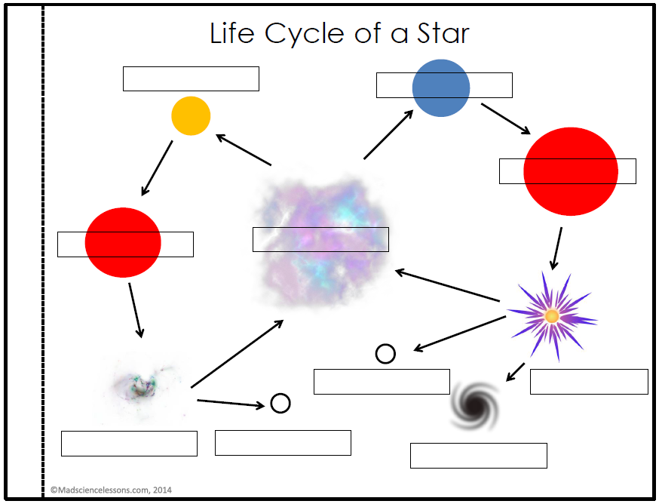

Name __________________________________________ Period _______