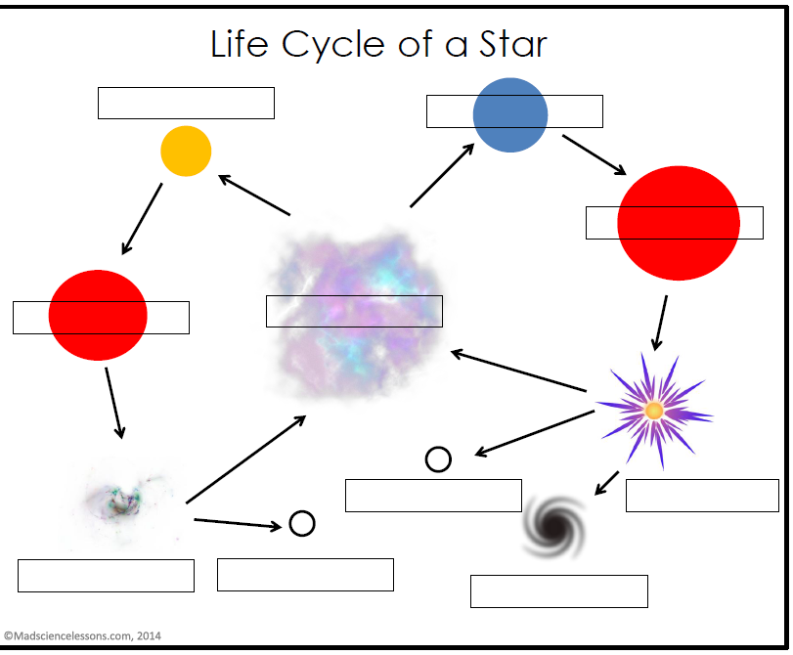

Stars with > 40 x the mass of the sun

Gravity pulls the dust and gas of a nebula closer together. A star is born when the gas and dust become so dense and hot that nuclear fusion starts.

Star forming nebula

Red super giant star

> 3 times the mass of sun

25 miles wide

Planetary nebula

Mass of our sun

Size of the Earth (8,000 miles)

Medium mass – a little smaller than our sun to almost 3 x our sun. Our sun will live about 10 B years years.

Low mass < .5 mass of the sun

Can live for 200 billion years

>3x mass of sun, shorter life

15x mass = only 10 million years

White dwarf star

Neutron star

Black Hole

Super Nova

Red giant star

High mass star

Low-medium mass star