Name_________________________________________________________Period _______
Modeling Mantle Convection Currents
QUESTION/PURPOSE: Manipulated Variable (MV) Responding Variable(RV)

How does heat affect fluid motion?
HYPOTHESIS (IF, THEN, BECAUSE) : Manipulated Variable (MV) Scientific Reason (WHY)
Responding Variable (RV)

Manipulated Variable Units | Responding Variable Units | Controlled Variable(s) Units
PROCEDURES  - Safety tips:  The fluid in the jar is no-toxic, but do not loosen the cap on the jar.  Be careful when working with an open flame  If you have long sleeves, push them up. NEVER reach across an open flame.  If you hair is long, tie it back.  Be careful of the hot jar.  - Shake the Carolina Convection Fluid (gently)  - Set up the equipment as shown.  - Ask the teacher to light the candle.  - Shine the flashlight on the fluid to observe its movement. Look at from all sides and the top. Draw what you see in the data table section. Use arrows to show what direction the fluid is moving. Record your observations in words – be complete! |  | MATERIALS Measuring Device  1 jar Carolina Convection fluid - CAPPED -  2 wooden blocks  1 tea candle  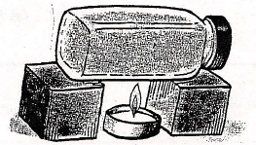

DATA TABLE

Side View Drawing:

Side View Written Description:

Top View Drawing:

Top View Written Description:

Use the what you learned in the lab and the diagram below to answer the questions on the back of this page.
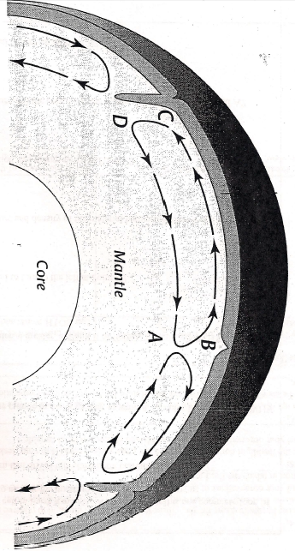
This figure shows convection currents cells in the mantle of the Earth. A convection cell is one complete loop of a convection current. Each neighboring cell moves in opposite directions.
Conclusion:

- Where does the heat come from that drives this convection current in the mantle?

- Where is the temperature of the mantle material greater, at point A or Point B? EXPLAIN your answer.

- Where is the density of the mantle material greater, at point B or Point C? EXPLAIN your answer.

- What causes the convection cell to turn left at Point B?

- What happens to the temperature and density of the material between points B and C?

- Why does the convection cell turn down at point C?

- What happens to the temperature and density of the mantle material between points D and A?

- What causes the convection cell to turn up at point A?

