Name: ___________________________________________________________ ______ Class Period:___________
Moon Talk
Wax, wane, crescent, gibbous, quarter, full, revolve, rotate, lunar … are words you need to know if you are going to speak moon. These describe the movements and phases of the moon. Antonia Astronaut, who incidentally is on a moon walk, is telling you some things about the moon. Match each label in the box (A-H) with the correct phase or position of the moon in the diagram. Then match the same labels with Antonia’s descriptions below. Write the correct letter on the line.
- First Quarter | C. Full Moon | E. Waxing Crescent | G. Waning Gibbous
- Third Quarter | - New Moon | F. Waxing Gibbous | H. Waning Crescent

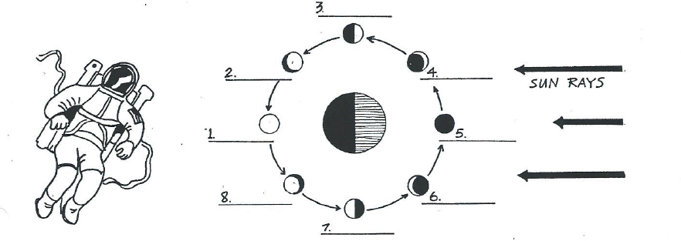
1. _____ “The moon lies between the sun and Earth so the side of the moon facing Earth is dark and the moon is not visible.”
2. _____ “More than a quarter of the moon is visible, and the visible portion is becoming smaller as the moon moves toward the third quarter phase.”
3. _____ “The moon has moved eastward in its orbit from the new moon phase and forms a 90° angle with the sun and Earth, and the moon appears half bright and half dark.”
4. _____ “Although less than a quarter of the moon is visible now, the visible portion is getting larger as the moon moves from the new moon phase toward the first quarter phase.”
5. _____ “The moon is aligned with the sun and Earth, Earth being in the middle. The entire side of the moon facing Earth is bright and visible.”
6. _____ “Less than a quarter of the moon is visible, and the visible part is getting even smaller as the moon moves toward the new moon phase.”
7. _____ “The moon is moving toward the full moon phase, and presently more than a quarter of it is visible on Earth.”
8. _____ “The moon, sun, and Earth are forming a 90° angle, so the side of the moon facing Earth is half dark and half bright. The visible part of the moon will be getting smaller as it moves toward the new moon phase.”

