Independent Work Occluded Fronts

Name ____________________________________________________________ Class ____________
Weather Patterns
Occluded Fronts

Recall that an occluded front occurs when a warm air mass is caught
between two cooler air masses and is cut off from the ground. The figures
below show two types of occluded fronts. The arrows indicate the direction
in which the air masses are moving. The type of occluded front that occurs,
A or B, depends on the relative temperatures of the two cold air masses.

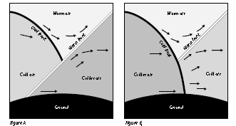

Use the figures to answer the following questions. TYPE your answers on a separate sheet of paper.

1. What are the differences between the occluded fronts shown in Figures A and B?
2. In Figure A, which air mass is densest? Which is least dense?
3. Why doesn’t the warm front in Figure B touch the ground?
4. Predict what would happen if both cold air masses had the same temperature.
5. Where would you expect clouds and precipitation to form in each type of
occluded front?

