Name ________________________________________________________________ Period ________

Independent Work Extra Credit: Properties of the Earth’s Interior

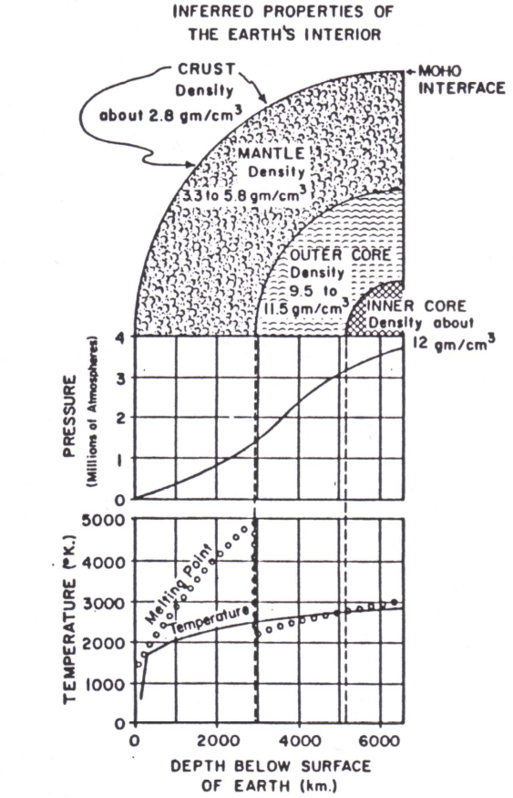
°K = °C + 273.15
°C = °K – 273.15

Name ____________________________________________________________________ Period __________
Extra Credit: Properties of the Earth’s Interior
Turn in only this page

- The Moho interface is the boundary between what two zones?

- What do you think the work ‘interface’ in #1 means?

- What is the temperature in °K at the interface between the mantle and the outer core?

- What is the temperature in °C at the interface between the mantle and the outer core?

- What is the pressure on the rock at this interface?

- What is the density of the rock at this interface?

- What is the temperature in °K at the interface between the outer and inner core?

- What is the temperature in °C at the interface between the outer and inner core?

- What is the pressure on the rock at this interface?

- What is the density of the rock at this interface?

- What is the temperature in °K at center of the Earth?

- What is the temperature in °C at center of the Earth?

- What is the pressure on the rock at this interface?

- What is the density of the rock at this interface?

- What is the relationship between depth below the Earth’s surface and temperature?

- What is the relationship between depth below the Earth’s surface and pressure?

- What is the relationship between depth below the Earth’s surface and density?

- Construct a graph using depth below the Earth’s surface and the density as your two variables. Mark the interface between the: mantle and the outer core, the outer core and inner core. Don’t forget to label the axis and give it a title.

