The Atmosphere

As altitude increases, air pressure decreases

Temperature. Temperature changes alternate in the different layers.

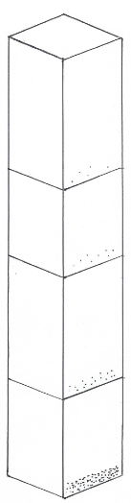

**Thermosphere**

This layer gradually blends into space. The air is thin, molecules are far apart. The molecules are very hot. The Northern Lights occur here.

**Troposphere**

The layer we live in, weather happens here, almost all of the mass of the atmosphere ishere.

**Mesosphere**

This layerprotects the Earth from most meteoroids

**Stratosphere**

The ozone layer protects the Earth from UV radiation from the sun and heats the troposphere.

The molecules in the upper atmosphere are far apart. Air pressure is very low.

As the altitude is increasing, the density of air and air pressure are still decreasing.

Air near the middle of the atmosphere is denser than air above it, and less dense than air below. The air pressure is also decreasing.

The weight of all the air above presses down, forcing molecules close together. Air is most dense and air pressure highest as the surface of the Earth

Layer, Temp, Facts

Density and AP

What is the atmosphere? A thin layer of gasses surrounding the Earth

How are the layers classified? By temperature

The 3 most abundant gases and their % in the atmosphere are:

1. Nitrogen 78%

2. Oxygen 21%

3. Other 1%

As altitude increases, air pressure does what? It decreases.

Why does air have pressure? Because it has mass.