Name _____________________________________________________________ Period _________
The Atmosphere
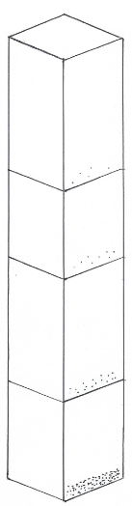
On the left hand side draw an arrow showing how pressure changes.

On the right hand side, draw an arrow showing how temperature changes.

What is the atmosphere?

How are the layers classified?

The 3 most abundant gases and their % in the atmosphere are:
1.
2.
3.

As altitude increases, air pressure does what?

Why does air have pressure?

Layer, Temp, Facts
Density and AP

