The Source of Earth’s Heat
You head home from school. The air is warm, moist and breezy. Raindrops begin to hit the pavement beneath your feet and you hear thunder in the distance. Lightning flashes. Huge anvil-shaped clouds hover overhead. A thunderstorm is headed your way.
What causes the weather, and its storms? Part of it has to do with the effects of heat from the Sun.

Solar Energy
Energy from the sun – called solar energy – is the source of most of the Earth’s heat on land, in oceans and in the atmosphere. Solar energy makes its way through the vacuum of space to the planet Earth by a process known as radiation. Some of this solar radiation is visible as light, and some of this radiation (heat for example) is invisible. The interaction

of solar energy with air, soil and water on the earth creates wind, rain and other elements of weather.
That sounds simple enough, right? Wrong! Only a small amount of the sun’s energy actually reaches the earth. The rest of the sun’s energy reaches out throughout space. Of the small amount that does reach the earth, about half is absorbed by the land and the oceans. The rest is reflected back into space or absorbed by the think blanket of air – the atmosphere – that surrounds the earth.
Earth has many different kinds of surfaces. Materials such as soil, rock and water absorb and give off energy at different rates. Look at the illustration below. A surface of snow absorbs only 5 percent of the solar radiation it receives, while a dark forest absorbs 95% of the solar energy it receives. The temperature
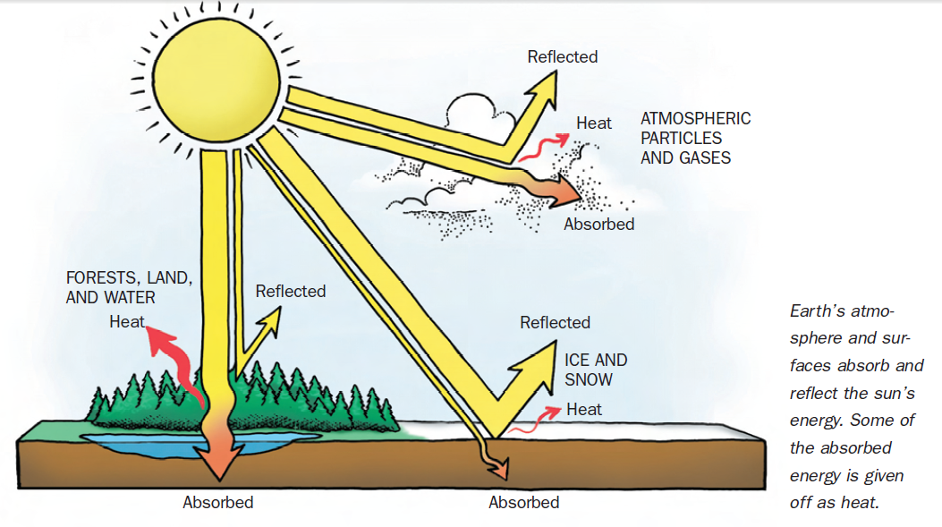

of a surface, such as snow or a forest, is an indication of the amount of the sun’s heat energy that has been absorbed. That is, it is a measure of how hot or cold a material is. Differences in how the earth’s surface absorb and give off energy are part of the reason that winds form and weather patterns change.

Thank Goodness for the Weather!
Without energy from the sun, all of the things that we take for granted on the earth, including the weather, would not exist. Weather distributes heat and precipitation (such as rain) around the globe. Gases and clouds in the atmosphere hold in the amount of heat needed to keep the earth livable The atmosphere affects the amount of solar energy that reaches the earth and protects it from the sun’s more harmful radiation. The atmosphere and its weather keep most of the earths surfaces warm enough for life to exist as we know it.

Name ___________________________________________ Period ______

The Source of Earth’s Heat
Instructions: Read “The Source of Earth’s Energy” story and answer the questions below. Tear off the front page before turning in.

- What is solar energy and how does it affect the earth? _________________

___________________________________________________________

___________________________________________________________

- By what process does solar energy reach the earth? ____________________

___________________________________________________________

- Only a small amount of the sun’s energy acturally reaches the earth. Explain what happens to the rest of the sun’s energy. _________________________

___________________________________________________________

___________________________________________________________

- Use the illustration on the previous page to fills in the names of the parts of the earth that are shown reflecting and absorbing solar radiation.
C.
A.
B.
- What happens to energy from the sun when it reaches the earth’s atmosphere and surfaces? ________________________________________________

___________________________________________________________

___________________________________________________________

___________________________________________________________

- Explain why snow reflects 95% of the solar energy that reaches it while a dark green forest absorbs 95% 95% of the solar energy it recieves. (Hint: Think about wearing a dark T-shirt or a white T-shirt on a sunny day)
___________________________________________________________

___________________________________________________________

___________________________________________________________

