Independent Work
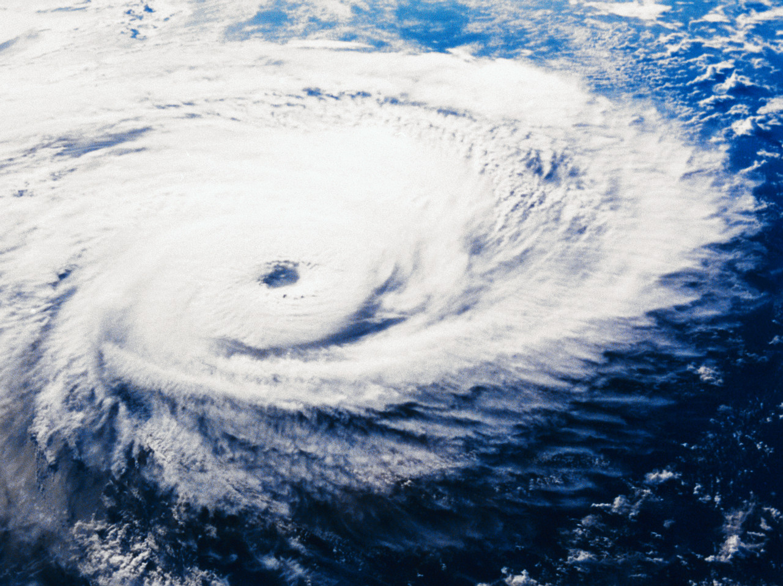

Tornadoes

You are a farmer from the Midwest whose farm was recently hit by a tornado. The insurance company needs an accurate account of everything that happened from the point the storm started until it was over. They will want to know about all the damage that was caused and what will need to be repaired. Details will help you get the best settlement to help rebuild your farm.

LAYOUT  2 points | Must be TYPED, 12 font and include a title. Written as a damage report to the insurance company.
BODY  13 Points | What exactly happened (describe the storm). What damage occurred? How did the damage occur?

Independent Work

Tornadoes

You are a farmer from the Midwest whose farm was recently hit by a tornado. The insurance company needs an accurate account of everything that happened from the point the storm started until it was over. They will want to know about all the damage that was caused and what will need to be repaired. Details will help you get the best settlement to help rebuild your farm.

LAYOUT  2 points | Must be TYPED, 12 font and include a title. Written as a damage report to the insurance company.
BODY  13 Points | What exactly happened (describe the storm). What damage occurred? How did the damage occur?

