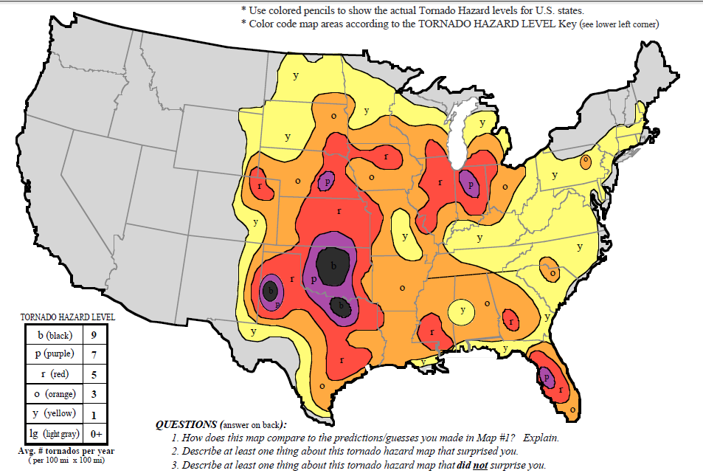

**U.S Tornado Hazard Map**

**Tornado Occurance by Time of Day**

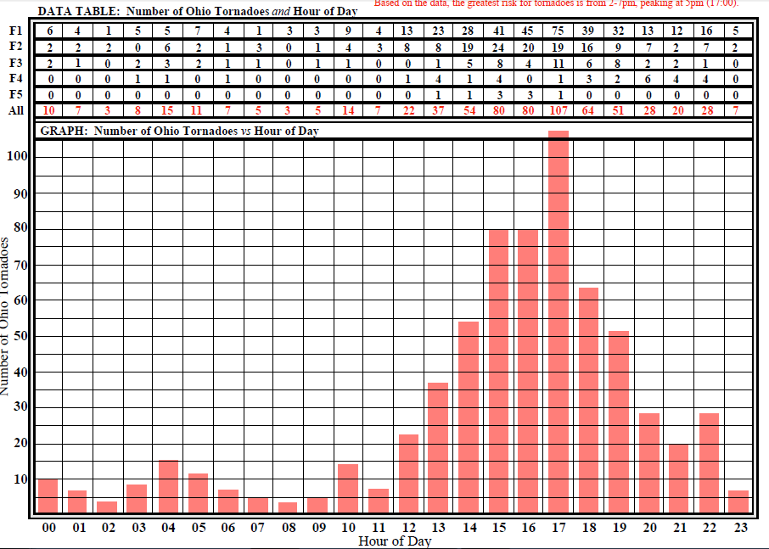

**Tornado Occurance by Month**

