#1 What is a Tornado?
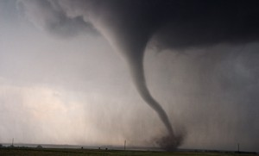
A tornado is a violently rotating column of air that descends from a thunderstorm. No other weather phenomenon can match the fury and destructive power of tornadoes. They can destroy large buildings, lift 20-ton railroad cars from their tracks, and drive straw and blades of grass into trees and telephone poles.
Tornado winds can reach 300 miles per hour.
In an average year, 1,200 tornadoes are reported in the United States, far more than any other place in the world.
On average, tornadoes cause 80 deaths in the United States every year and 1,500 injuries, although averages do not mean very much when it comes to these storms. In 1998, for example 130 people died in tornadoes in the United States, including 42 who were killed in an outbreak in central Florida and 34 who died in a single tornado in Birmingham, Alabama. Most human casualties are people in mobile homes and vehicles. The deadliest single tornado struck on March 18, 1925. In three and a half hours, it traveled 219 miles through Missouri, Illinois, and Indiana, killing 695 people.
The Super Outbreak of 1974
The worst tornado outbreak in history occurred in the United States April3-4, 1974. A total of 148 twisters touched down in 13 states and Canada (Figure 1). It lasted 16 hours. A total of 330 people were killed, and 5,484 were injured.
The Super Outbreak was the most tornadoes in the most states, but it was not the deadliest tornado outbreak. That was the Tri-State Tornado of March 18, 1925 mentioned above.
Property damage form the Super Outbreak was estimated at $600 million. Especially hard hit were the states of Alabama, Kentucky, and Ohio. The most damaging and deadly twister hit Xenia, Ohio. A tornado touched down southwest of Xenia and destroyed half of the town. The death toll was 34 people in Xenia and damage to property totaled $100 million.
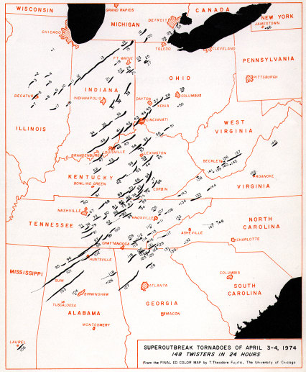Figure 1 Map from Super Outbreak 1974

#2 How Does a Tornado Form?
In order to form a tornado, you need three very different types of air to come together in a particular way:
- Beginning in spring and continuing through summer, low-level winds from the south and southeast bring plentiful supply of warm tropical moisture up from the Gulf of Mexico into the Great Plains.

- The second ingredient is from down off of the eastern slopes of the Rocky Mountains or from out of the deserts of northern Mexico come other flows of very dry air that travel about 3,000 feet above the ground.

- The last thing you need are the prevailing winds at 10,000 feet sometimes accompanied by a powerful jet stream, race overhead, carrying cool air from the Pacific Ocean.

When a storm system high in the atmosphere moves east and begins to lift the layers, it begins to build severe thunderstorms that spawn tornadoes. As it lifts it removes the cap, setting the stage for explosive thunderstorms to develop as strong updrafts form. If the rising air encounters wind shear, it may cause the updraft to begin rotating, and a tornado is born.
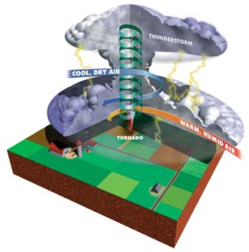

# 3 How Does a Tornado Warning System Work?
There are five basic steps in the National Weather Service warning system. Every part of the system has to work for the greatest number of people to get the warning in time.
Step 1. The Tornado Watch
The forecasters at the Storm Prediction Center in Kansas City, Missouri, use satellite pictures, radar reports, numerous weather charts, and other tools to predict where severe thunderstorms and tornadoes are likely to occur. When they determine it's likely that a severe storm may occur, they issue a tornado or severe thunderstorm watch. Watches may be issued hours before a severe storm hits an area.
Step 2. Spotters
Once a tornado watch has been declared, the spotters get busy. Spotters — the National Weather Service's eyes in the field — report critical weather information as it is happens. If a Spotter sees a tornado, she/he immediately transmits this information to the National Weather Service through the information network known as Skywarn. This changes the tornado status from a watch to a warning. Most tornadoes are detected by the use of Doppler radar, but the spotter system still accounts for reporting many tornadoes. In order to become a Spotter, you need to pass a Skywarn training program.
Step 3. Civil Defense and the State Police
Once a tornado watch is issued, the National Weather Service alerts the state and local civil defense organizations and the state police. This allows authorities to prepare for a possible emergency.
Step 4. Informing the Public
If it seems likely that a tornado or other weather emergency will hit an area; the National Weather Service has a direct line to local media offices so that they can relay the information to the public as quickly as possible.
Step 5. The Users
Users include everyone within the severe thunderstorm or tornado warning area. The best way to save lives is to reach the greatest number of people possible to tell them that they need to prepare. Even if every other step in the warning system works, it does little good unless the users know what to do, and act. The best way to receive timely tornado warning advisories is through use of a NOAA Weather Radio with a warning alarm and battery backup.
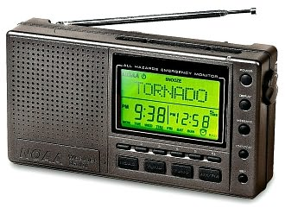
A watch or warning?
Don’t confuse a “watch” with a “warning”. There is a big difference.
Tornado Watch: When National Weather Service forecasters issue a Tornado Watch, they are making a forecast that tornadoes are possible in your area. It is a time to remain alert to signs of approaching storms and to make sure that you are prepared for an emergency.
Tornado Warning: This is an emergency message. A tornado has been sighted in your area, or weather radar indicates one is present. Now is the time to get to safety, to put your emergence plan into action.

Tornado do’s and nots!
The National Weather Service and the American Red Cross have put together these basic tips about tornado safety:
- Seek shelter immediately, preferably underground in a basement, or in an interior room on the lowest floor such as a closet or bathroom.
- Stay away from windows.
- Get out of your car or your mobile home and seek shelter in a sturdy structure. In the open, lie flat in a ditch.
- Protect your head form flying debris.
- Do not try to outrun a tornado in your car.
- Do not seek shelter under a bridge under an overpass. The idea that these are safe shelters is just plain wrong.

#4 How Are Tornadoes Measured?
Dr. T. Theodore Fujita ("Dr. Tornado") was a pioneer in the study of tornadoes and severe thunderstorm phenomena. In 1971, he created the Fujita Tornado Damage Scale to estimate tornado strength based on damage surveys. Since it's extremely difficult to measure tornado winds directly, this is the best way to classify them.
The scale goes up to F5 — or up to 318 mph. It's possible that a tornado could generate winds above the scale, but it has never been recorded. On May 3, 1999, an Oklahoma University Doppler radar remotely sensed tornado wind speeds above ground of 318 mph at Bridge Creek, Oklahoma — the highest winds ever found near Earth's surface, and right at the threshold of being F6 winds.

Fujita Tornado Damage Scale — Developed by "Dr. Tornado", T. Theodore Fujita of the University of Chicago
Scale | Wind Estimate (mph) | Typical Damage
F0 | < 73 | Light damage.  Some damage to chimneys and TV antennas; breaks twigs off trees; pushes over shallow-rooted trees.
F1 | 73-112 | Moderate damage.  Peels surface off roofs; windows broken; light trailer houses pushed or overturned; some trees uprooted or snapped; moving automobiles pushed off the road. The beginning of hurricane wind speed is 74 mph.
F2 | 113-157 | Considerable damage.  Roofs torn off frame houses, leaving strong upright walls; weak buildings in rural areas demolished; trailer houses destroyed; large trees snapped or uprooted; railroad boxcars pushed over; light-object missiles generated; cars blown off highway.
F3 | 158-206 | Severe damage.  Roofs and some walls torn off frame houses; some rural buildings completely demolished; trains overturned; steel-framed hangar-warehouse-type structures torn; cars lifted off the ground; most trees in a forest uprooted, snapped, or leveled.
F4 | 207-260 | Devastating damage.  Whole frame houses leveled, leaving piles of debris; steel structures badly damaged; trees debarked by small flying debris; cars and trains thrown some distances or rolled considerable distances; large missiles generated.
F5 | 260-318 | Incredible damage.  Whole frame houses tossed off foundations; steel-reinforced concrete structures badly damaged; automobile-sized missiles generated; trees debarked; incredible phenomena can occur.
F6-F12 | 319 to sonic | Inconceivable damage.  Should a tornado with the maximum wind speed in excess of F5 occur, the extent and types of damage may not be conceived. A number of missiles such as iceboxes, water heaters, storage tanks, automobiles, etc. will create serious secondary damage on structures.

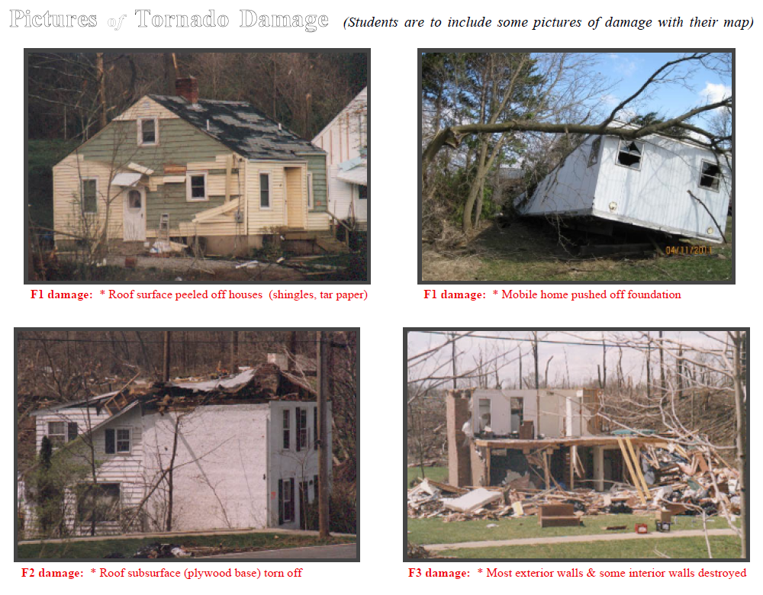

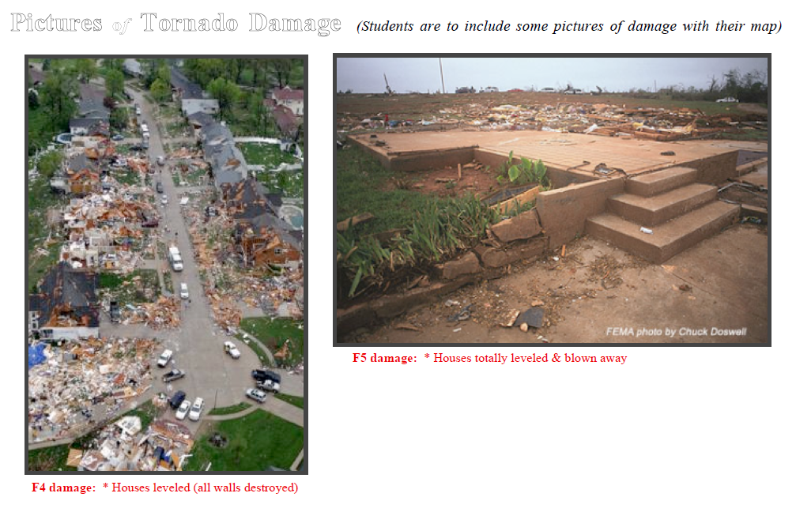

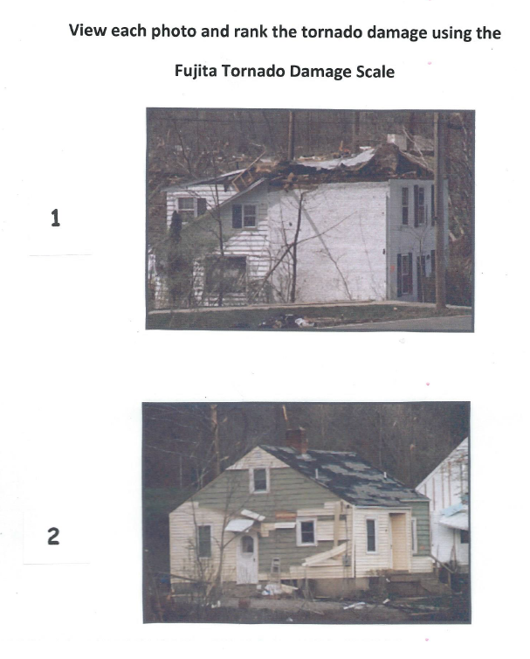

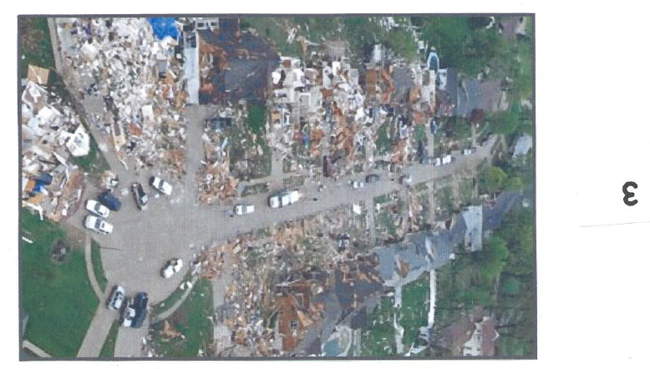

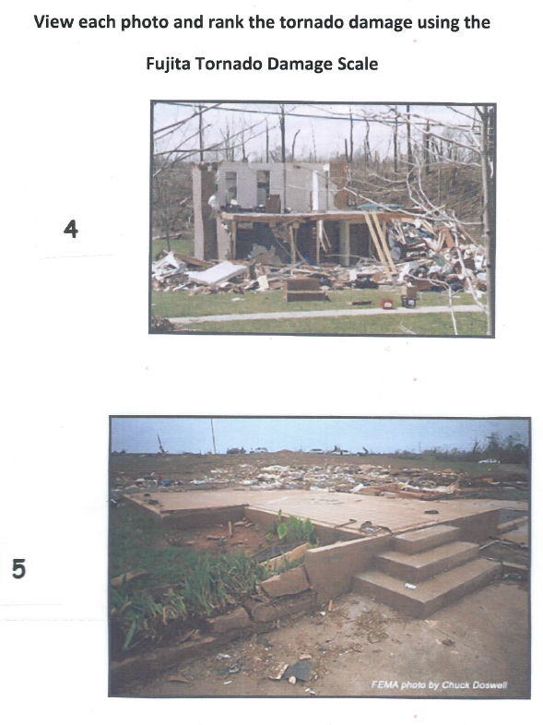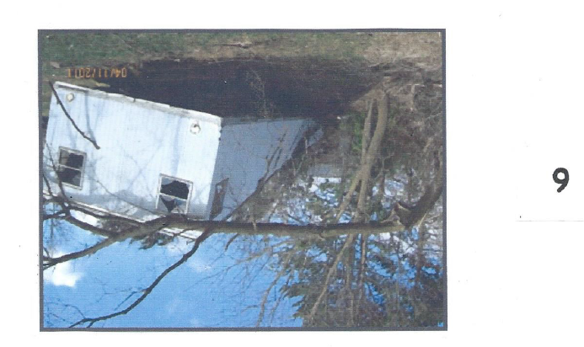

#5 Tornado Occurrence by Month
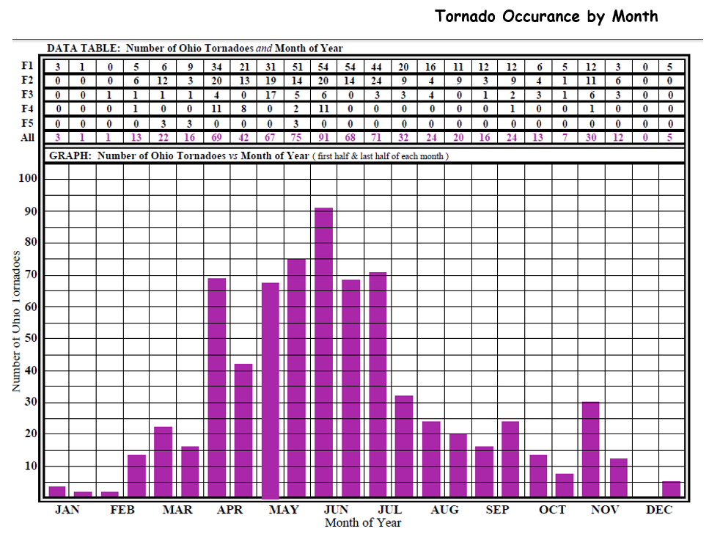

#6 U.S. Tornado Hazard Map
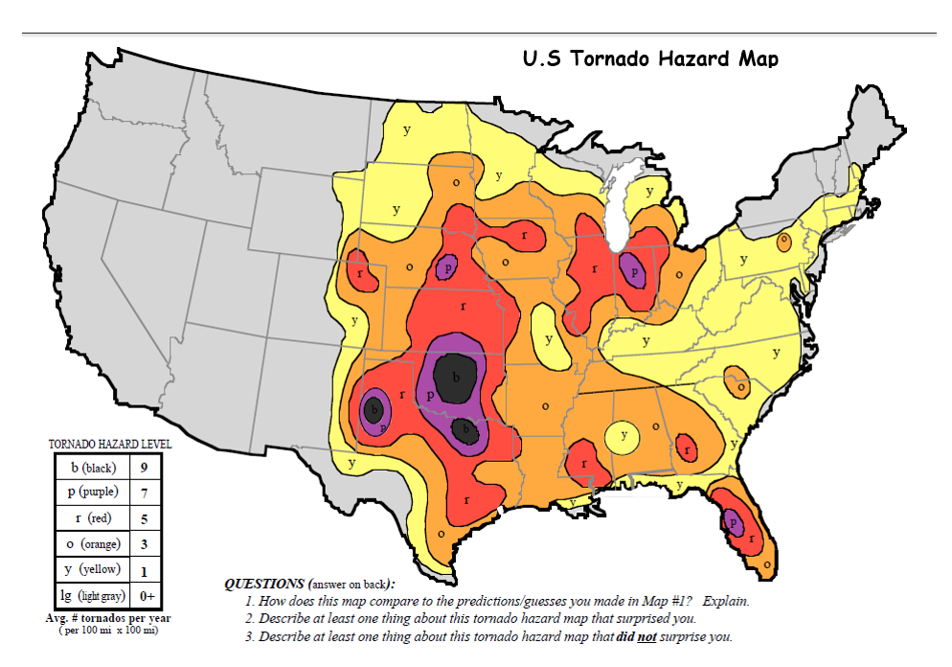

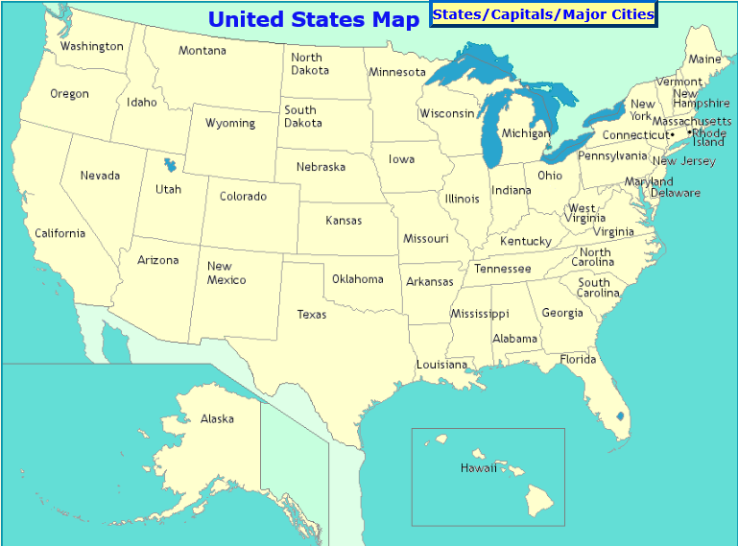

#7 Tornado Occurrence by Time of Day
